Portfolio Project – Arcane Glass Remake

# Reasoning

When I first created Arcane Glass as a project for my university course, I was unhappy with how it ended. Many of the features were left unfinished, in a basic form, or were not created in the first place. For this reason, I want to make the game again with the goal of completing these features.

# Pre-Production

## Concept

Arcane Glass is a single-player mobile game set in a medieval fantasy setting. Players take on the role of an alchemist and potion merchant and craft their own potions to sell to travellers. Players collect ingredients from the wilds that they then combine to create fantastical potions with properties derived from the ingredients. These potions can then be sold to travellers who visit to aid them in their daily lives. Potions are crafted with an eclectic mix of tactile tools, each of which can modify and amplify the effects of the ingredients used.

## Inspirations and Influences

As this is a remake, I will of course be influenced primarily by the successes and failings of the previous version. That said, there are some more influences that the game initially drew from: Potion Craft, and Potion Maker.

Potion Craft (Niceplay Games) is possibly the biggest inspiration for Arcane Glass. It puts the player in the role of an alchemist who craft potions at the request of their customers. Players physically interact with their tools and ingredients by moving them about. As an example, to stir a cauldron, players must move the spoon from side to side. The game is available on PC, PlayStation, Xbox, and Nintendo Switch.

Potion Maker (Sinsiroad Studios) is another influence on the game. Players take the role of an alchemist and combine ingredients to fulfil customers’ requests. Multiple ingredients can be combined to increase the selling price of the potion created, and potions can be enhanced to dramatically increase their prcie at the risk of destroying them. Potion Maker is available for Android and iOS.

Visually, the game draws inspiration from simple, low-poly games with vibrant colour palettes. Such inspirations are Light Fingers (Numizmatic), Monument Valley (Ustwo Games), and Slime Rancher (Monomi Park).

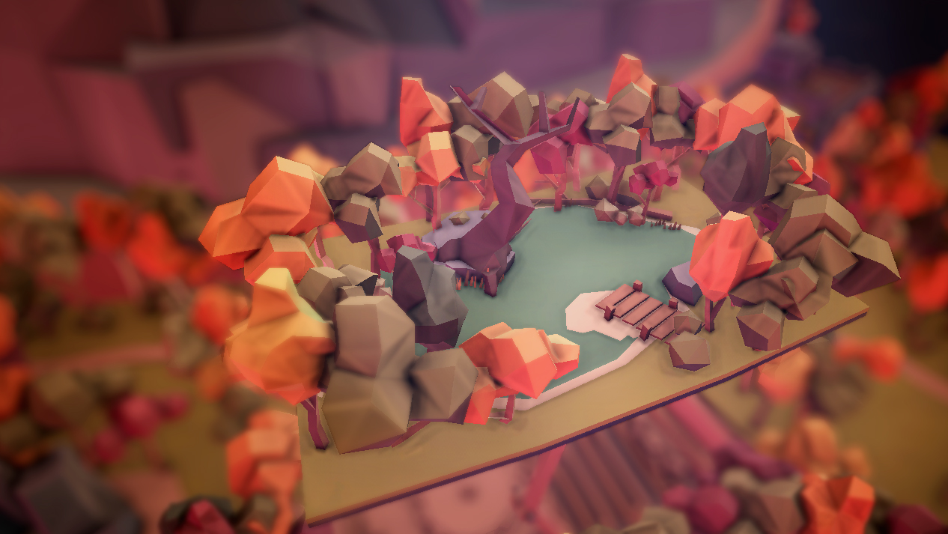  

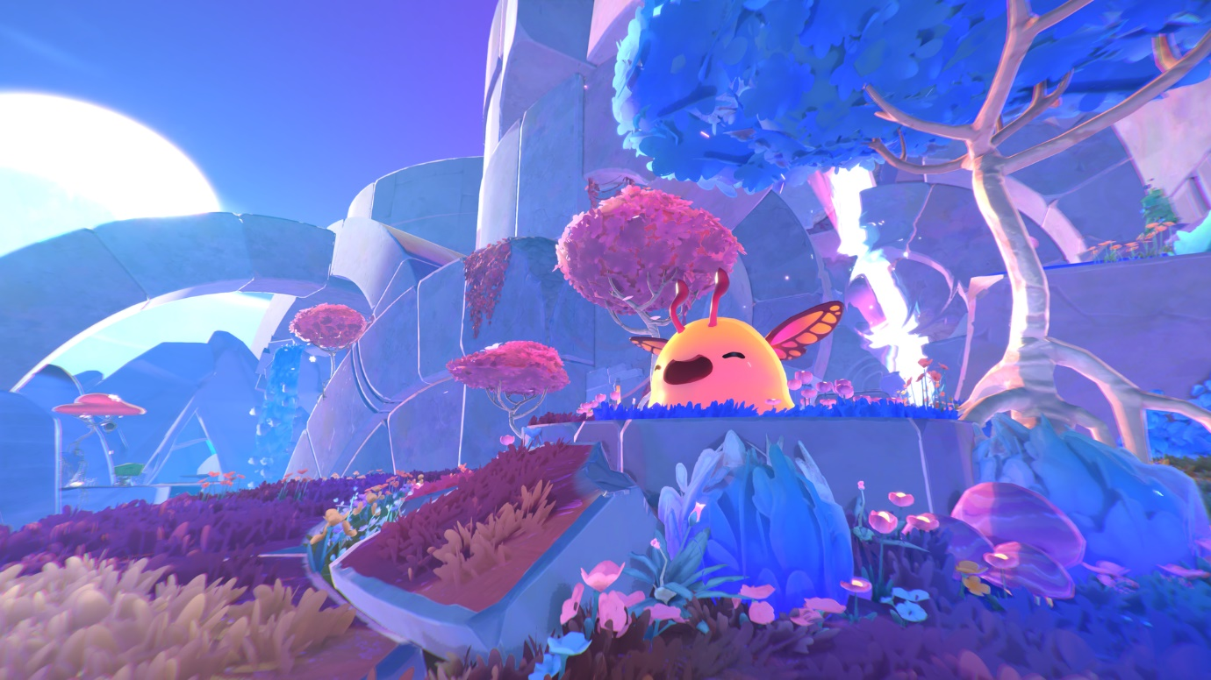

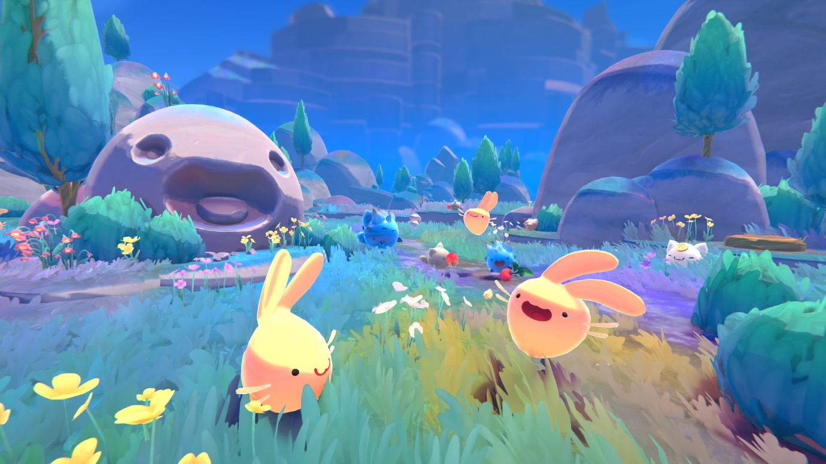

## Gameplay Mechanics

### Overview

The game is single-player and created for mobile devices. The player takes on the role of an alchemist and potion merchant in a fantasy environment. They gather exotic Ingredients from The Wilds, a variety of environments with different Ingredients in each, to craft Potions with effects depending on what was used. The player can then sell these Potions or the raw Ingredients to Travellers for Coins. These Coins can be used to purchase Ingredients or ready-made Potions from Travellers or purchase new Tools from Merchants.

### Exploring

The player can explore The Wilds in a travelling cart to collect Ingredients. The Wilds consists of multiple environments from bright and sunny beaches to dark and dingy forests, from windswept valleys to tall mountains, all connected by a central town that acts as a hub for trade. These locations each offer unique Ingredients, so players are encouraged to move about in their traveling cart to craft a variety of Potions. Each location is sub-divided into smaller areas that offer different Ingredients while keeping the location’s general theme.

As the player explores, time passes from day to night. This gives the player the option to visit the same location at different times for new atmospheres and new Ingredients since some only appear in the day or only at night.

### Crafting

When the player has collected a few ingredients, they can craft a Potion. Potion crafting is an involved process that requires analysing each Ingredient for its properties, enhancing the desired properties while neutralising the undesired properties through using various Tools, and finally combing the processed Ingredients into a Potion.

Each Tool has a unique operation and function. Some Tools are automatic, such as the Boiling Pot, and some are manual, like the Chopping Board. Automatic Tools do not require player interaction to process Ingredients but may require oversight so as to not overprocess the Ingredients. Manual Tools require the player to perform a specific action to process the Ingredient. Each Tool uniquely changes the properties of the Ingredients, so different Tools must be used if the player wants specific properties in their Potions. Each Ingredient can only be processed once.

### Travellers

Travellers are merchants, adventurers, and wanderers that the player will interact and trade with on their journey. Each Traveller will have wants and needs that the player can choose to fulfil with their Potions. The Player can buy from and sell to these Travellers and can alter the price by haggling at the risk of losing the deal. The player may wish to buy Ingredients or Potions that they don’t have or are running low on. Rarely, the player may encounter a merchant who can offer them bulk buying opportunities and new Tools to expand their Potion making.

The town location offers the player a central hub with which to trade with large merchant guilds. These guilds tend to be more expensive and less willing to haggle but allow the player an easy route to buying many Ingredients or selling excess Ingredients and Potions that they are finding hard to sell.

## Concept Art

### Environments

### Ingredients

### Travellers

### Miscellaneous

# Production

Arcane Glass will be created in Unity as this is what I am familiar with.

## Coding

### Menu

To start the game, I created a quick menu and a script that allows the player to start the game.

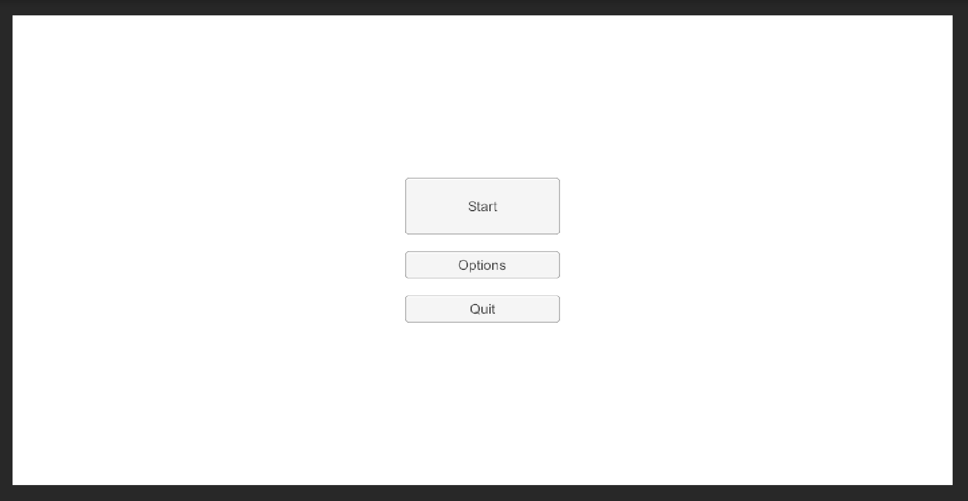

The menu is simple and just has a few buttons which are contained within a canvas.

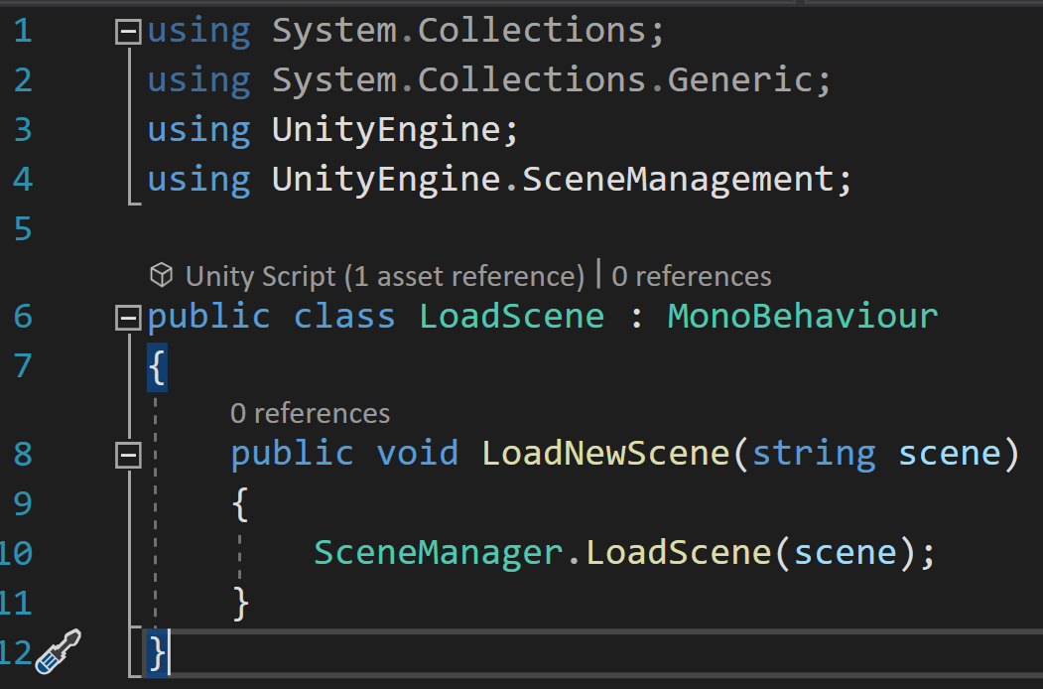

Attached to the canvas is a script accessed by the buttons. This script has a method for loading a new scene with a string. I would prefer this to use scenes themselves, but these cannot be used.

### Inventory System

#### Item Data

In the first version of Arcane Glass, I attempted to create an inventory system but ran into problems when getting its UI to function. I decided to follow the same tutorial as I did before but closer and modify it at the end. Hopefully, this will solve my problems.

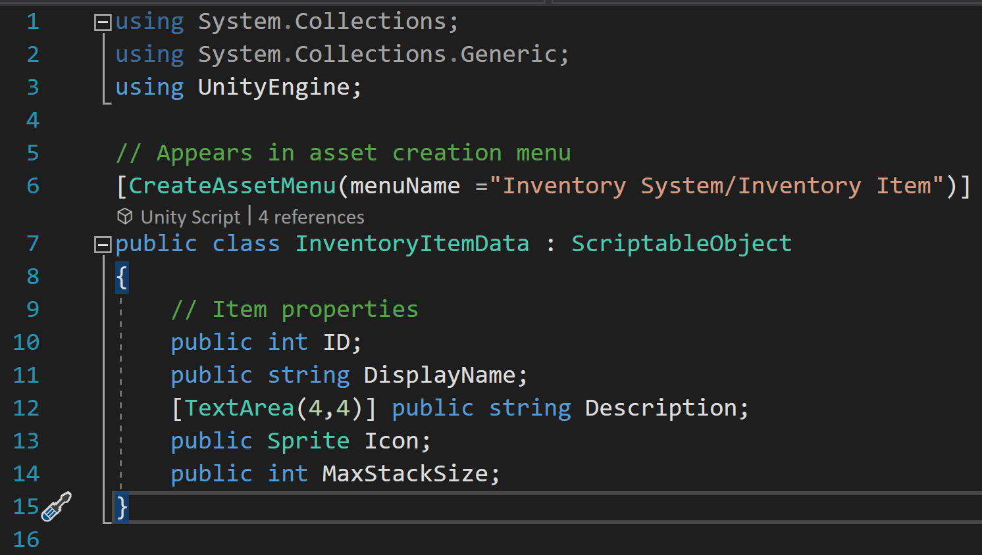

The tutorial starts by creating inventory item data. This script contains the information contained in an item when it is within an inventory. It also allows items to be created with the asset creation menu.

#### Inventory Slot

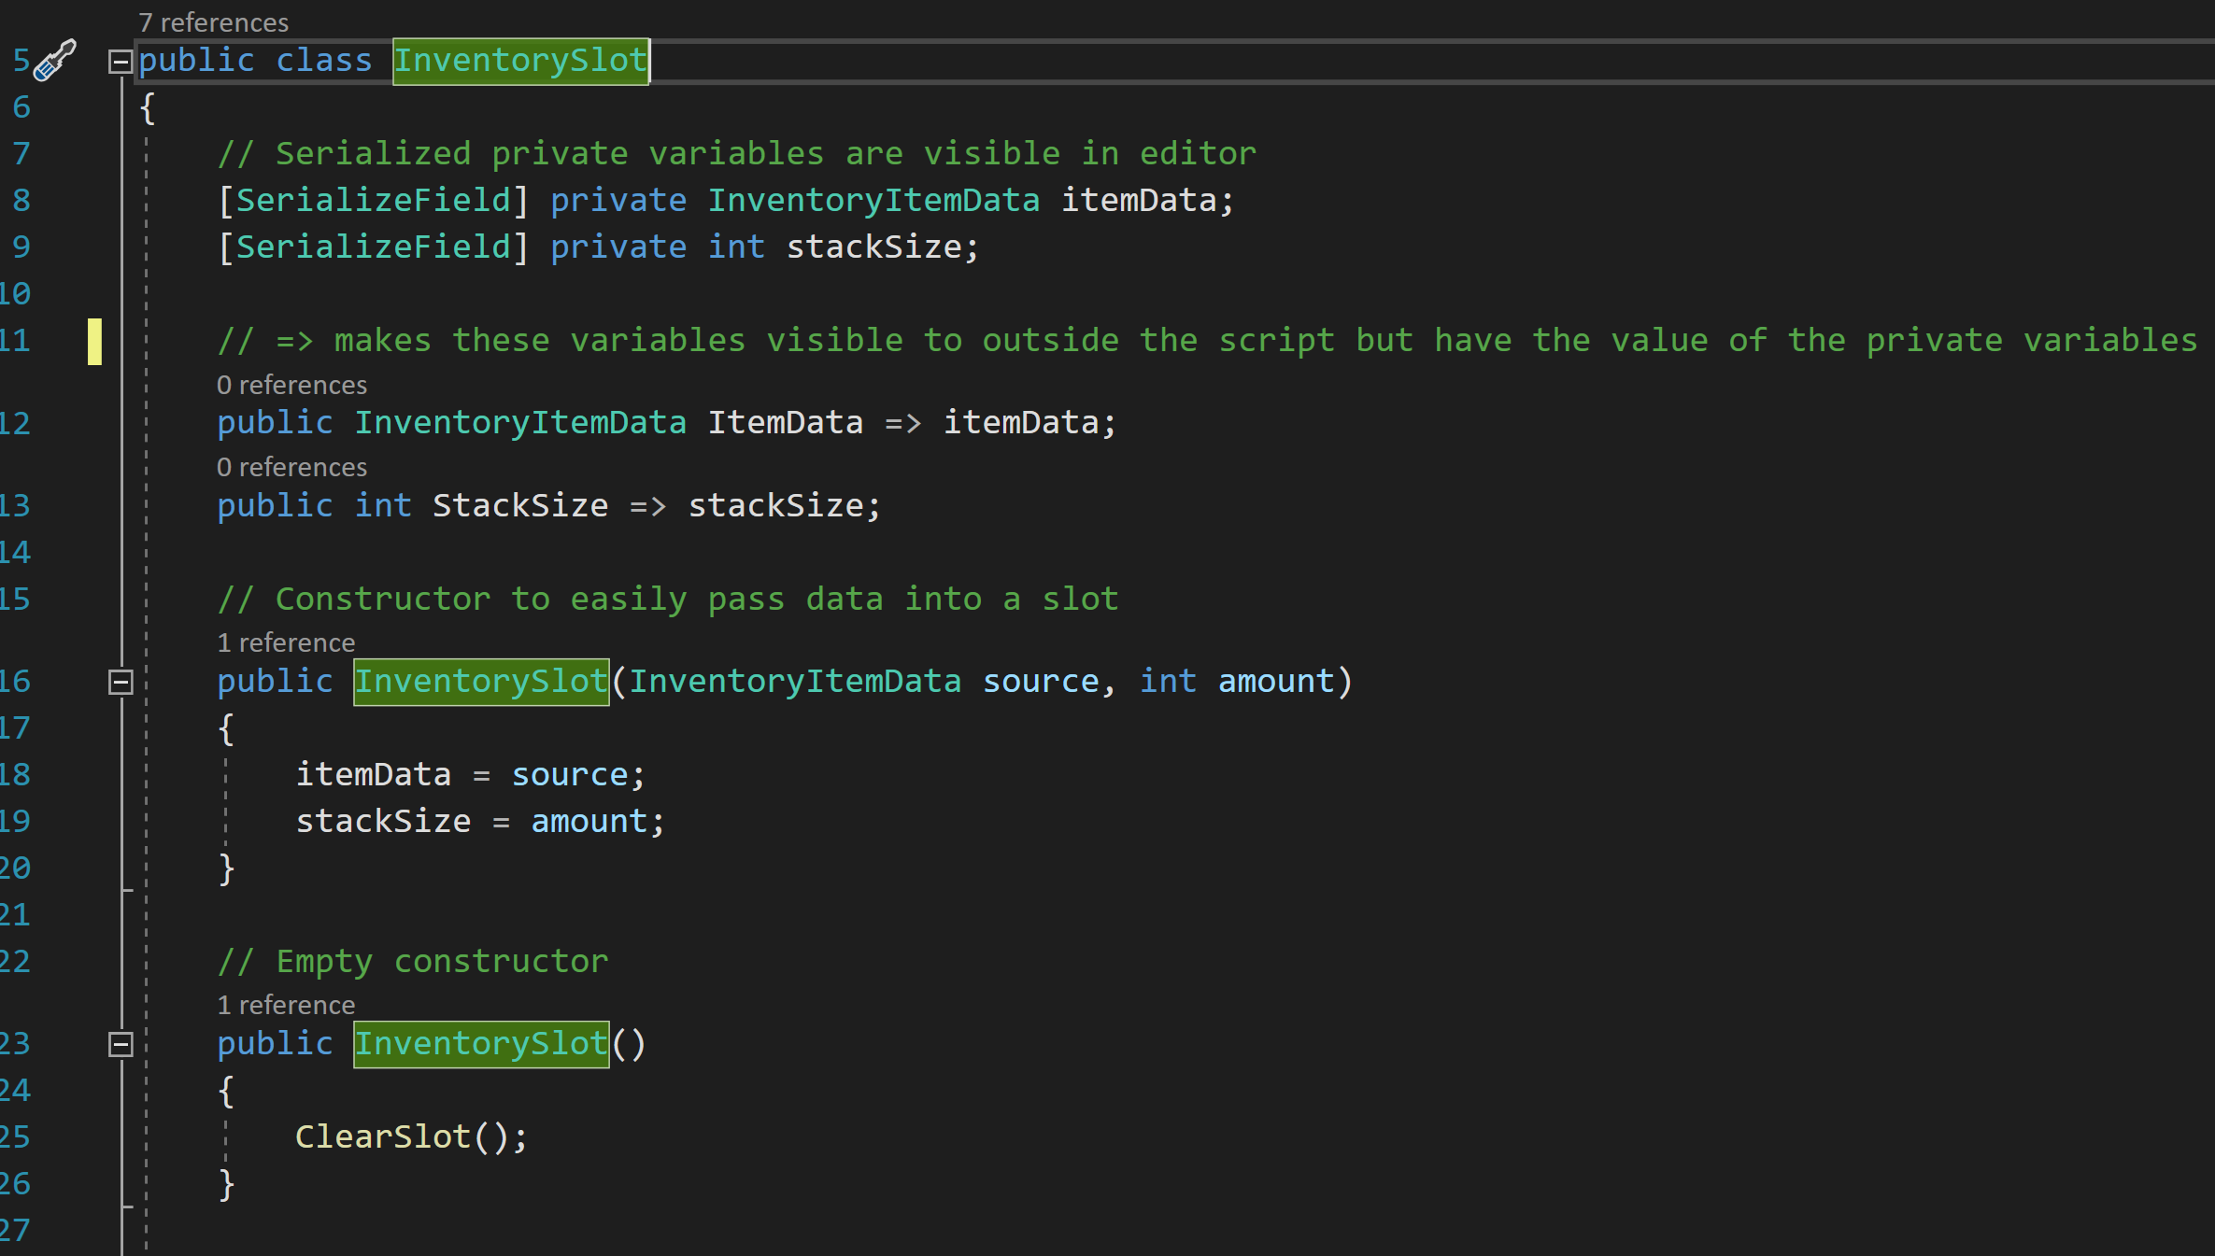

Next was the creation of the inventory slot. This stores a quantity of one type of item data. It starts by creating the variables for the item data and it quantity. Then, it creates two constructors. One takes in an item data and a quantity and assigns these to the variables in the slot. The other constructer creates an empty slot if the required data isn’t provided.

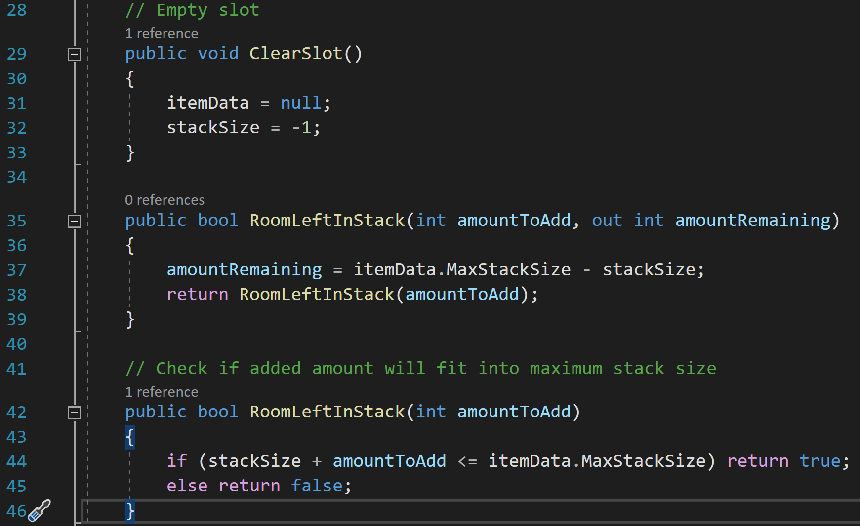

A clear slot is one in which the item data is null, and the quantity is -1. There is also functionality for determining if there is room left in the slot for more of the item, which returns true if there is space, or false if there is not.

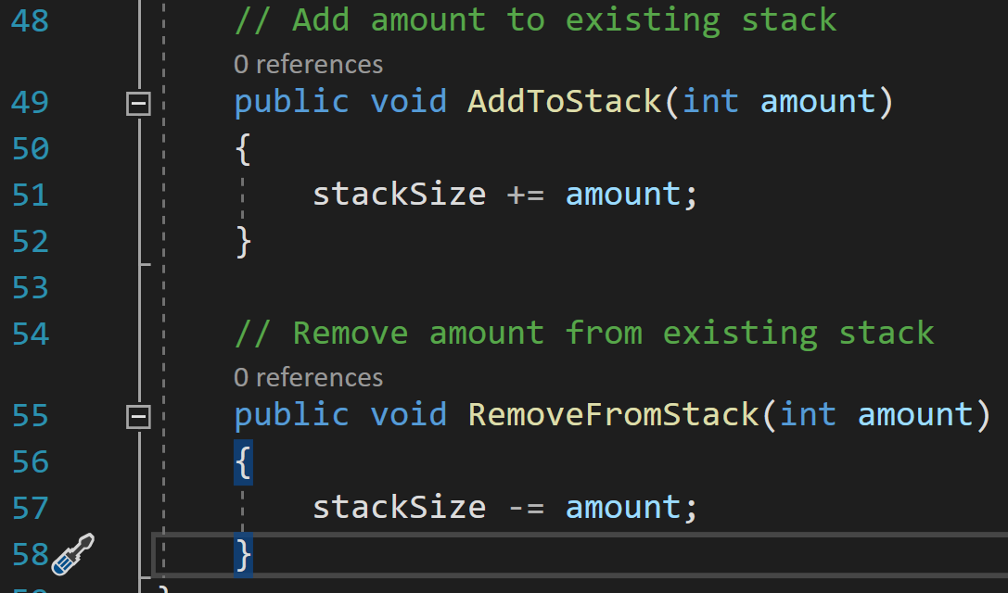

Finally, there are two short methods for adding and removing items from the stack.

#### Inventory System

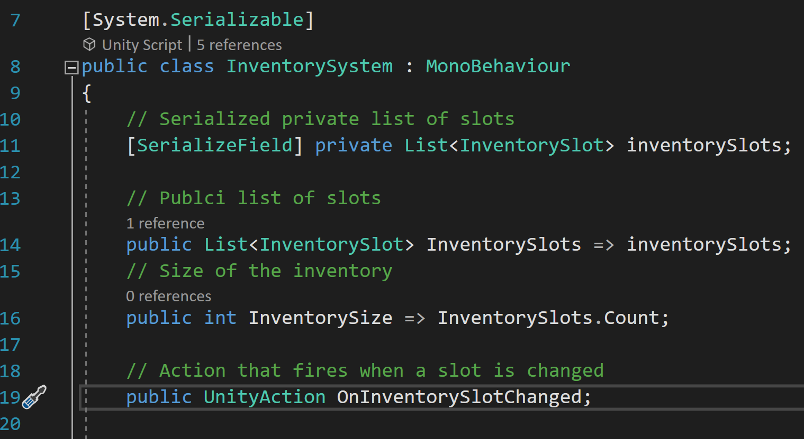

The inventory system was created next. This houses a number of inventory slots. It starts by creating some variables, as well as an event that will trigger when a slot is changed.

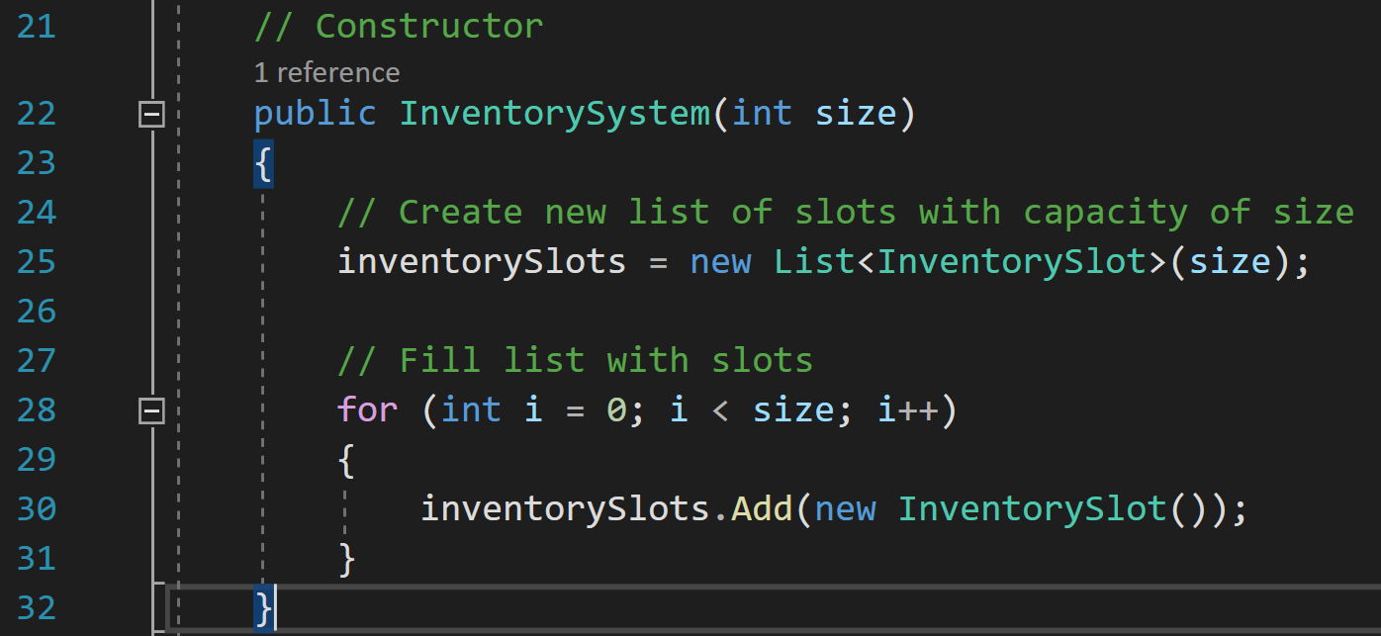

Next, the inventory system includes a constructor for creating an inventory which creates a new list of slots.

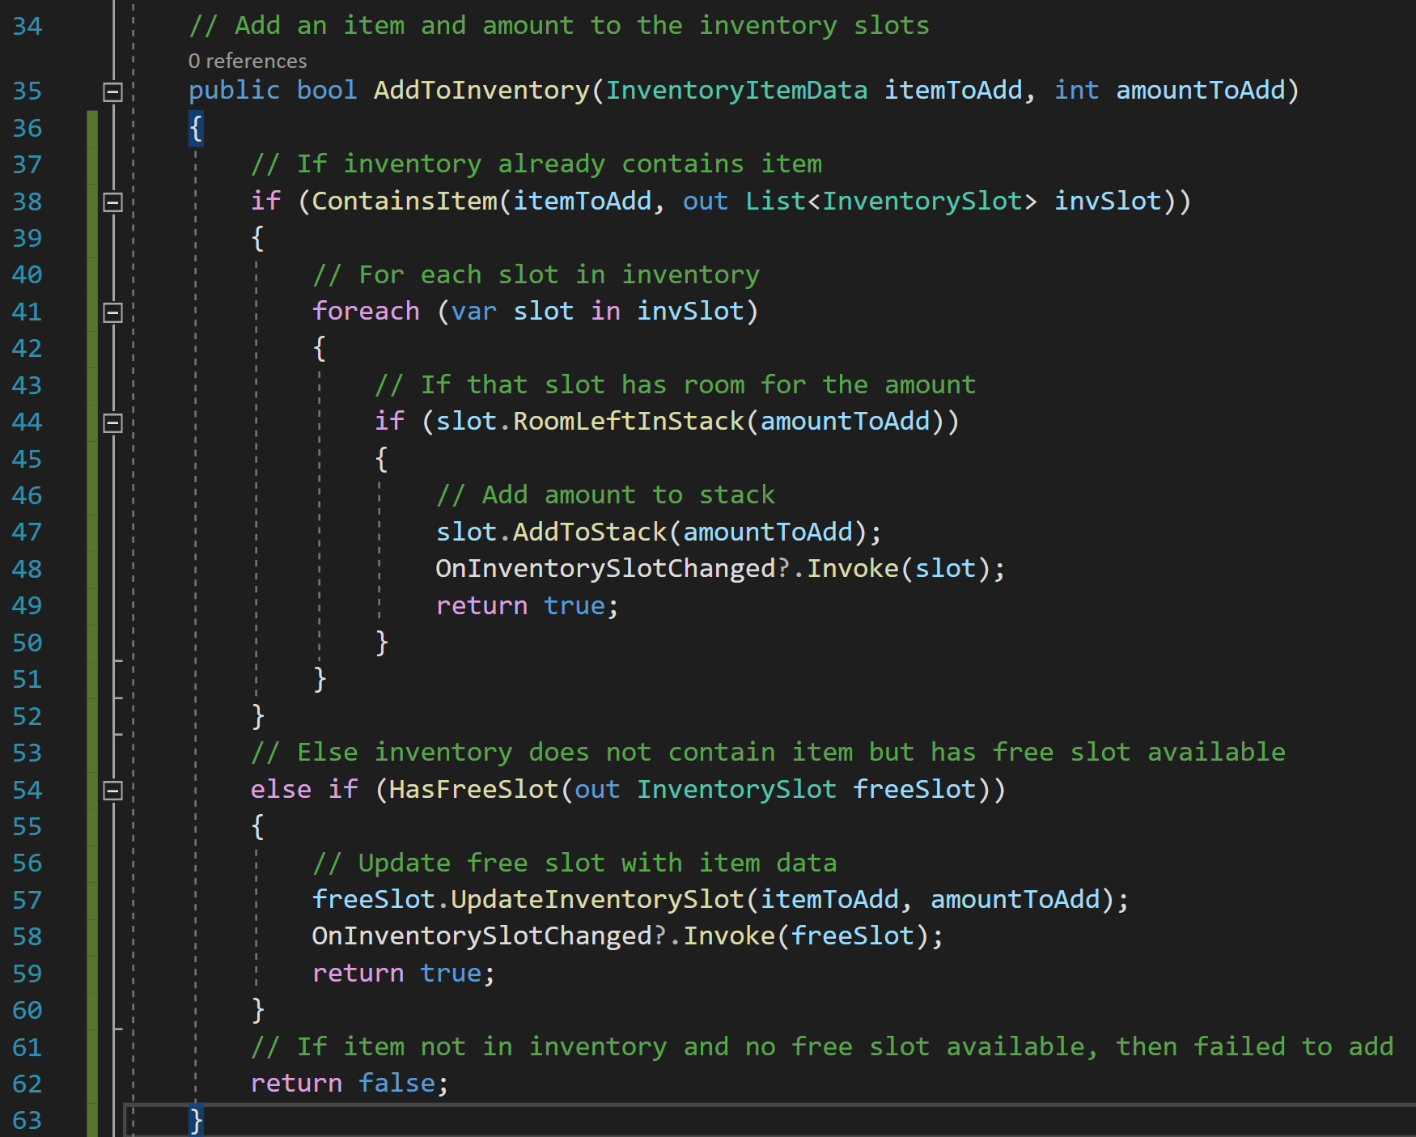

The first method of the inventory system is to add an item to the inventory. This attempts to add the item to an existing stack, add it to a new slot if it isn’t already in the inventory, or fail if neither condition can be met.

When adding to an existing stack, the inventory checks if that item type already exists in the inventory. If it does, it runs through all slots with that item until it finds one that can take the full amount of the item.

If a slot cannot be found, or the item is not in the inventory, an empty slot is located, and the item is added there. If there is no space for a new slot, then the item cannot be added to the inventory and it is not added.

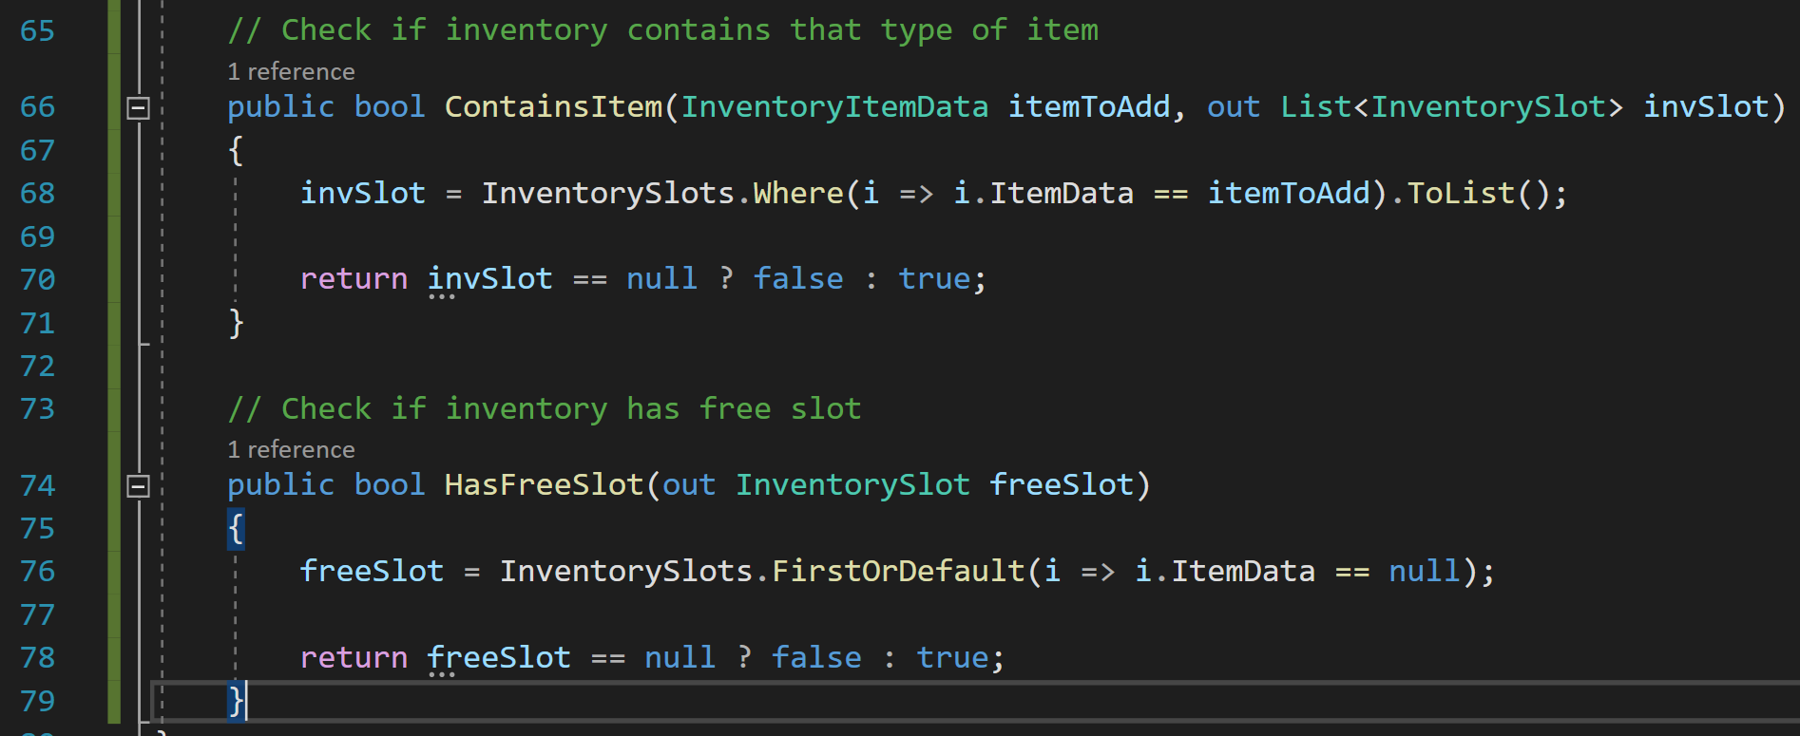

This method relies on two other methods. ContainsItem checks to see if the inventory already contains the item. It does so by creating a list of all inventory slots with item data that matches the item to be added. This method can produce the list of slots, and return true if the item has been found or false if it has not.

HasFreeSlot checks if the inventory has a free slot available. It does this by finding the first slot that has null data. If one has been found, then the method returns true, and the free slot can be pulled out. If a slot has not been found, then the method returns false as the free slot is null.

#### Inventory Holder

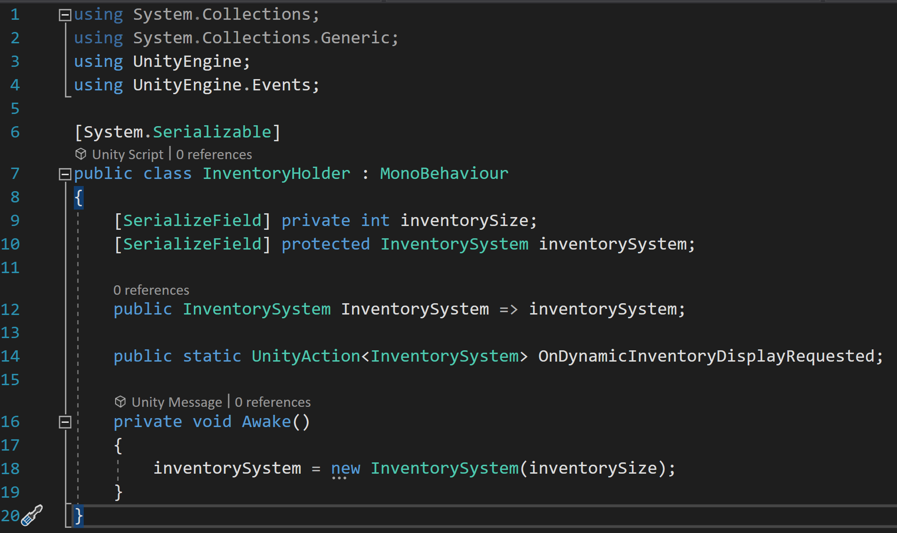

Finally, the first the backend concludes with creating the inventory holder. This script creates an inventory system when it first awakens. It also creates an event which will link with the UI.

#### Inventory Slot UI

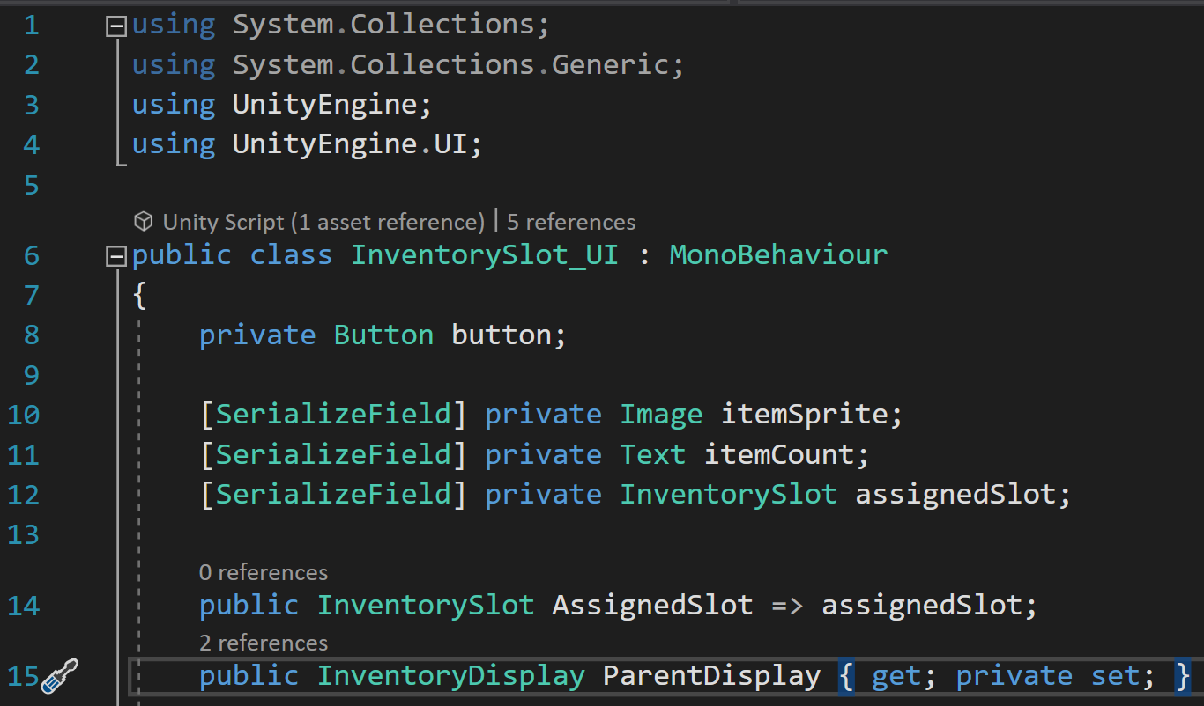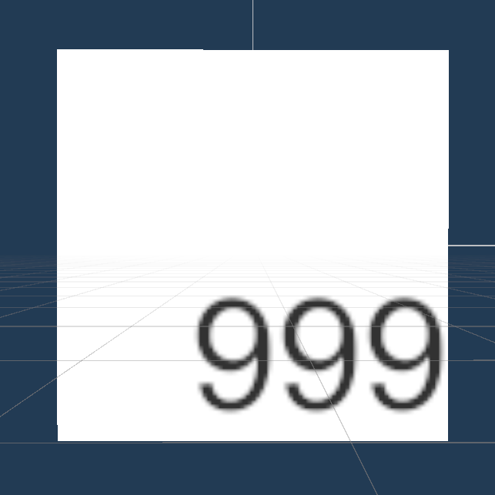

With the backend complete, it was time to move on to the visual part. I started by making the slot UI, which first declares some variables corresponding to parts of its user interface representation.

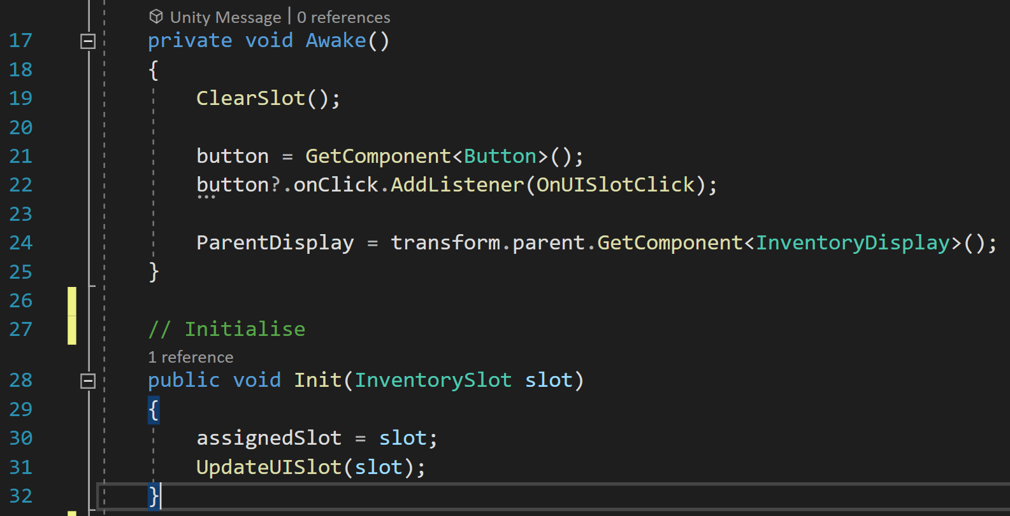

Next, I created two methods. The first, Awake, activates when the object is first started in the scene. It clears the UI slot, gets the button overlayed on top of the slot and adds a listener to trigger the OnUISlotClick method when clicked. It also gets its parent display, a script which collects the slot elements. The next method, Init, is used to initialise the slot.

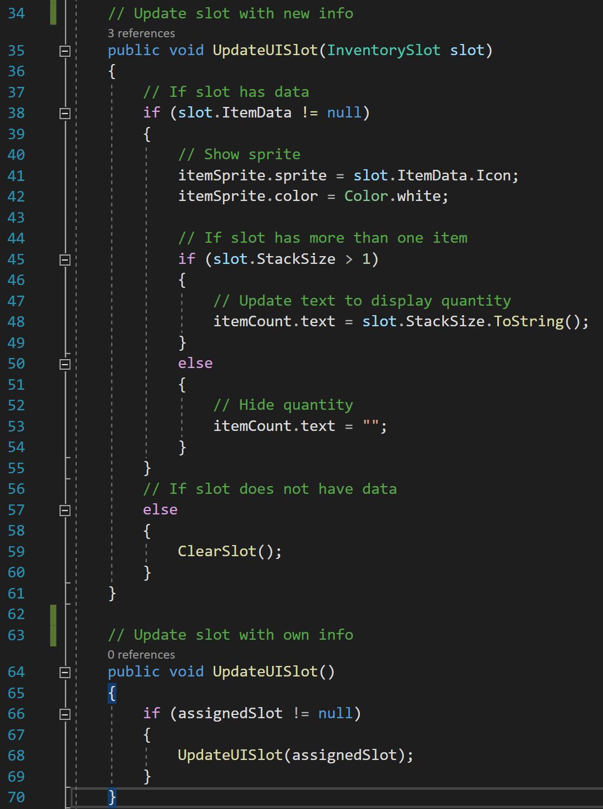

The next part of the UI slot script updates the UI slot. The first method first checks if the slot has any data. It clears the slot if it does not have data or shows the slot if it does before moving on to check if the stack size of the item is greater than 1. If it is, the text is updated to match. The text is hidden if the stack size is 1.

The second method allows the slot to be updated without taking in any information.

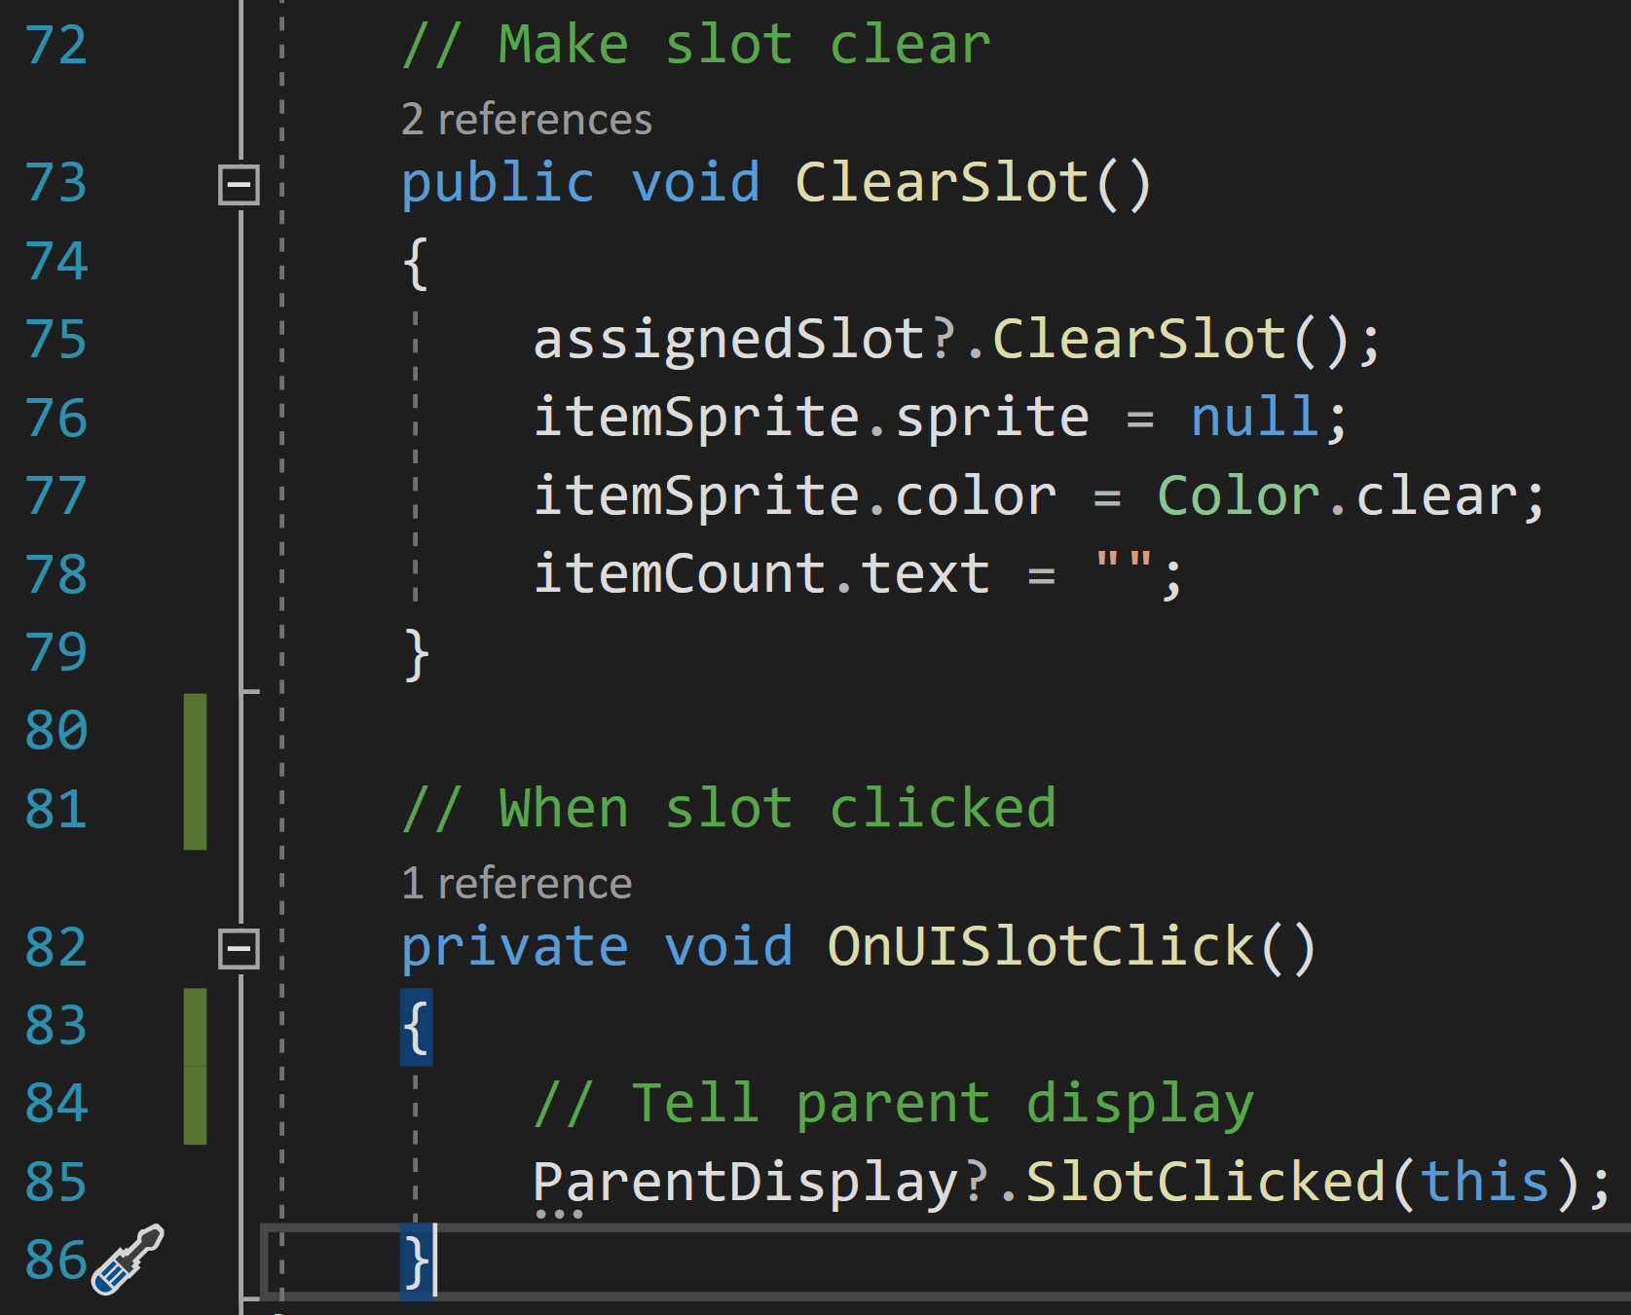

Finally, the script makes two more methods. ClearSlot sets the sprite, colour, and text to clear. OnUISlotClicked is triggered when the slot is clicked on. This simply informs the parent display of this action.

#### Inventory Display

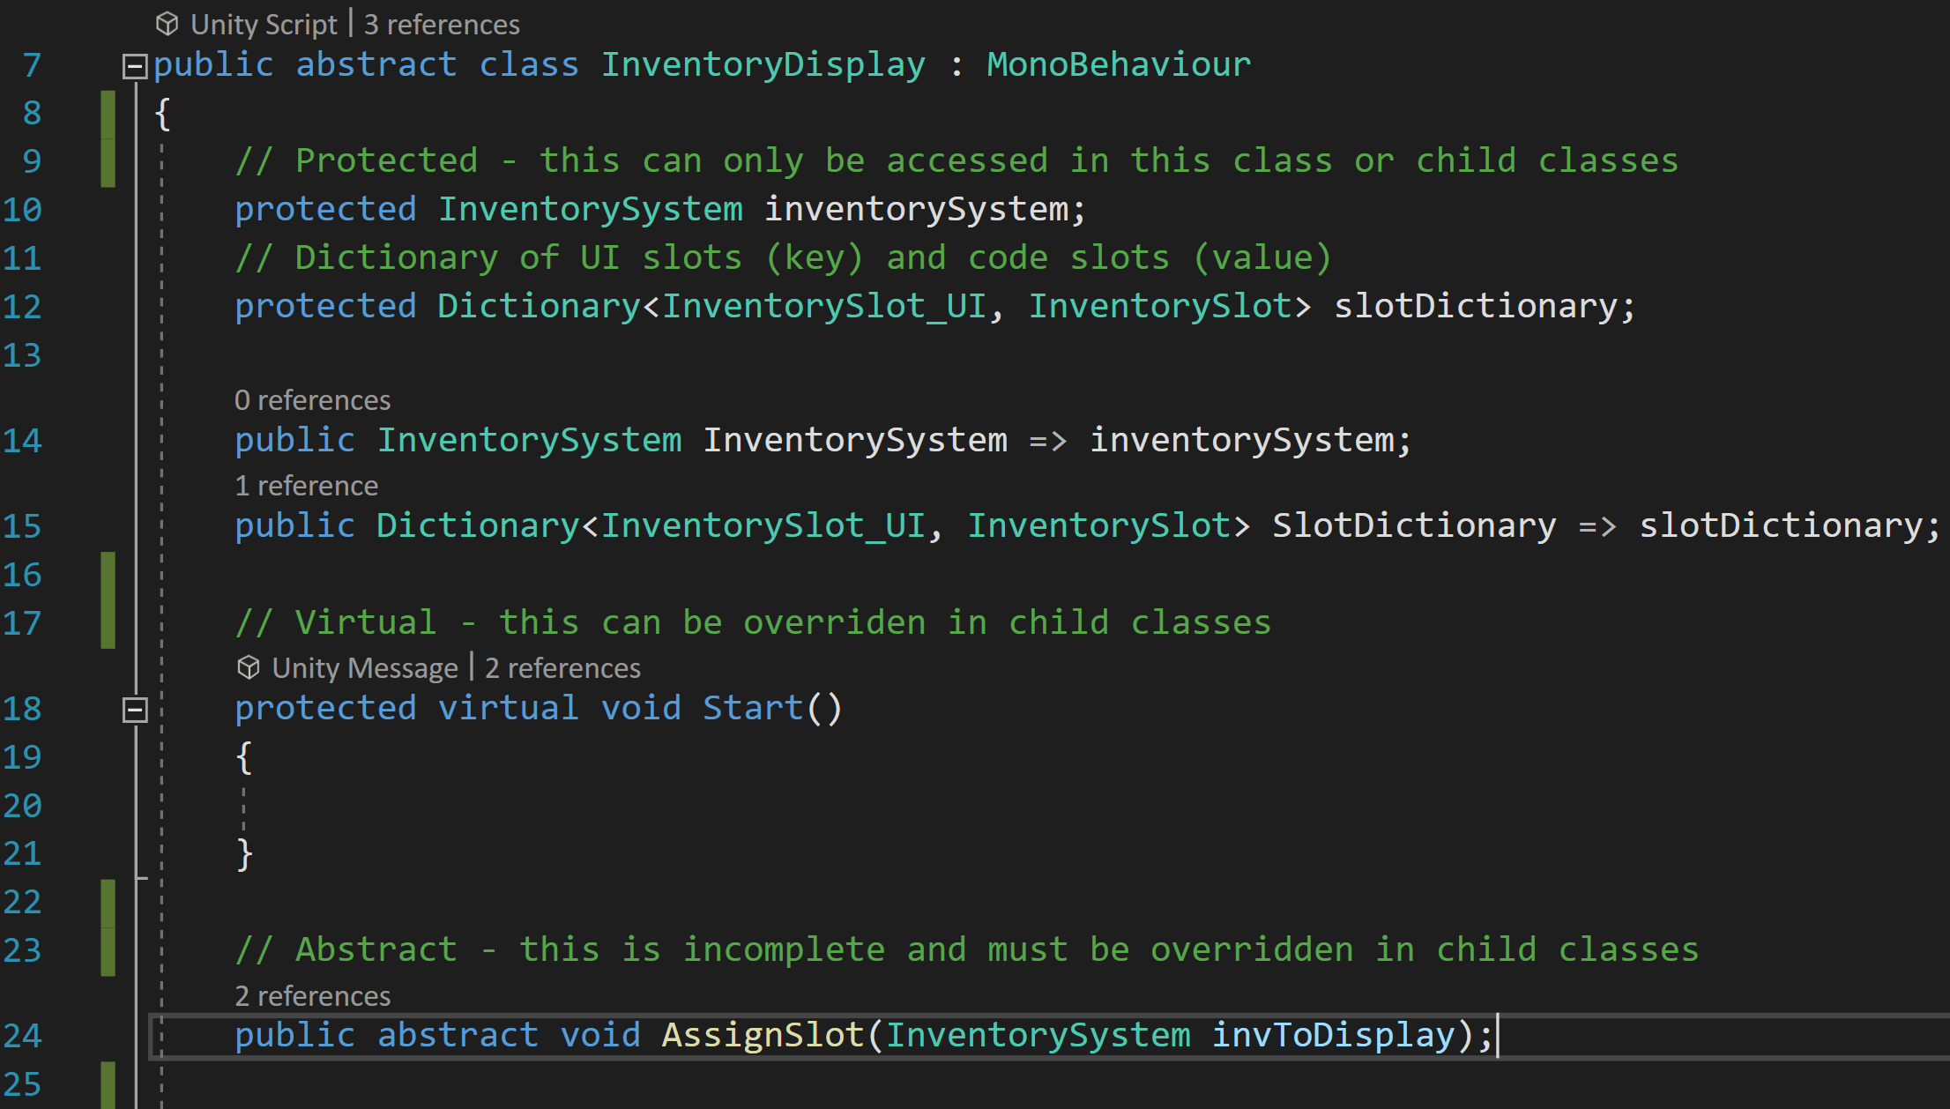

The inventory display script is meant to be inherited from and not used itself which is why it is an abstract class. This script starts by declaring some variables: a protected inventory system, and a protected dictionary of UI slots and code slots. It also creates two methods. The virtual Start method can be overridden by child classes, and the abstract method AssignSlot must be overridden in child classes.

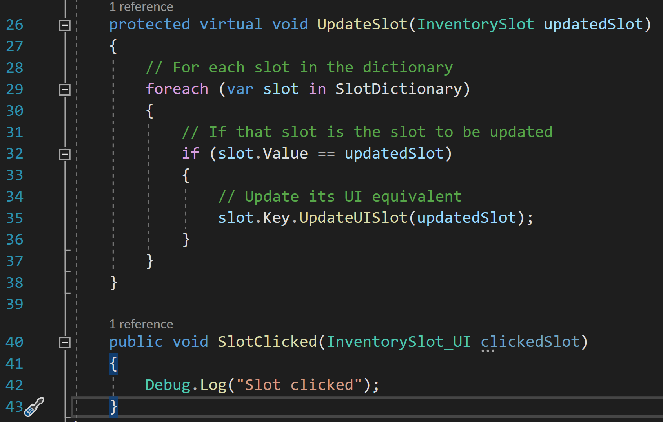

Finally, the script creates two more methods. UpdateSlot is a virtual method, meaning it can be overridden in child classes, but it contains some code itself. For each slot in the dictionary, it checks if that slot is the slot to be updated and updates its visual representation.

The SlotClicked method simply logs that it was clicked for the time being.

#### Static Inventory Display

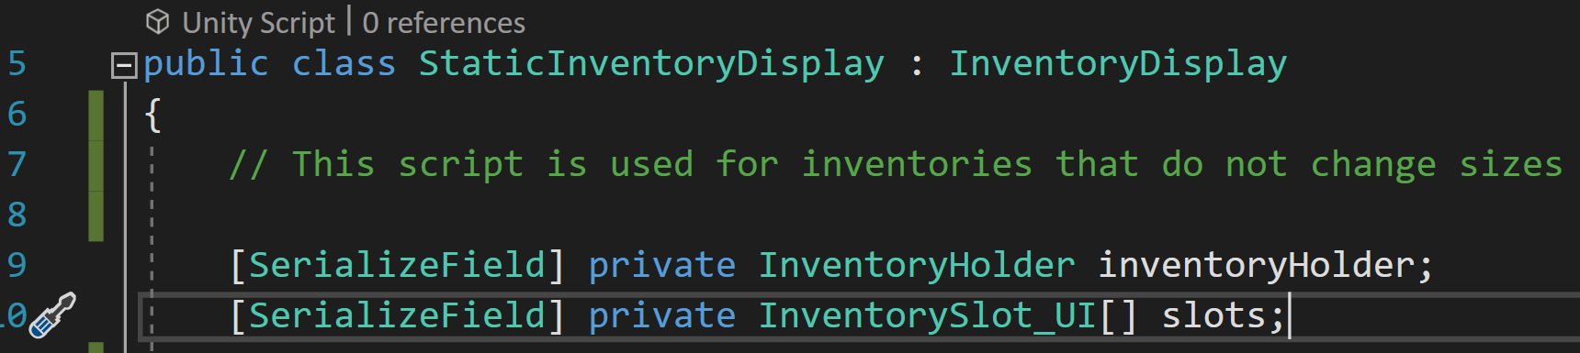

The static inventory display is a type of display used for displaying inventories that do not change sizes. It has two variables: an inventory holder, and a list of UI slots.

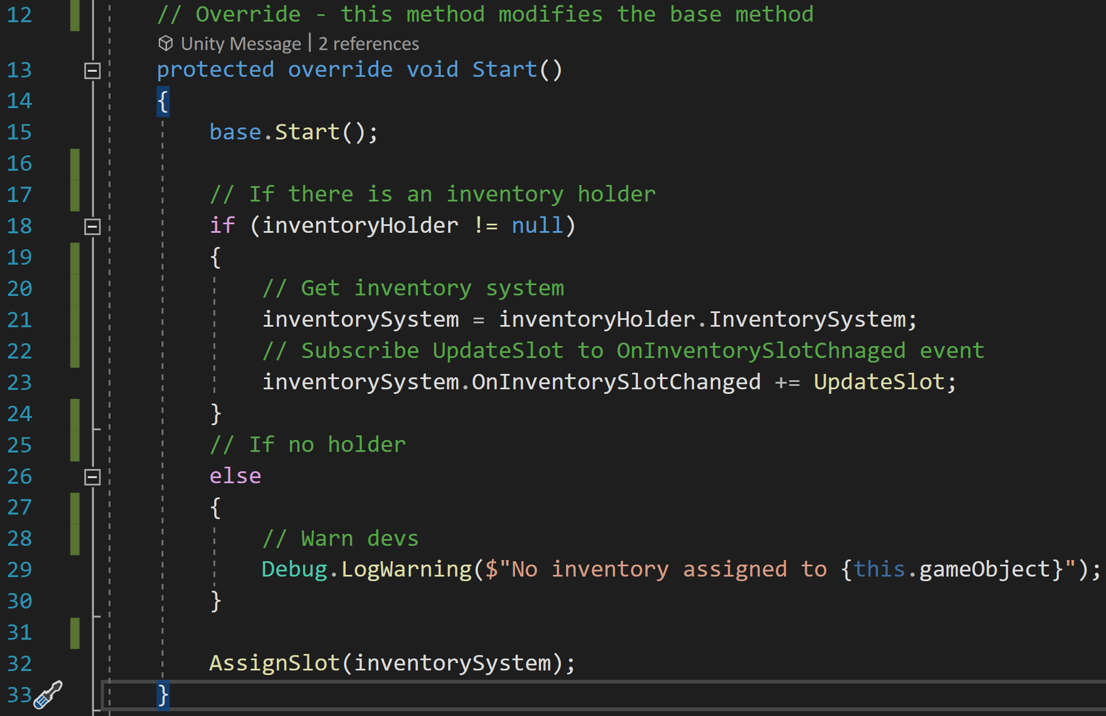

The first method created overrides the base Start functionality. It checks if there is an inventory holder and gets the system from it and subscribes the UpdateSlot method to the OnInventorySlotChanged event. If there is no holder, it creates a warning message. Next, it triggers the AssignSlot event with the inventory system.

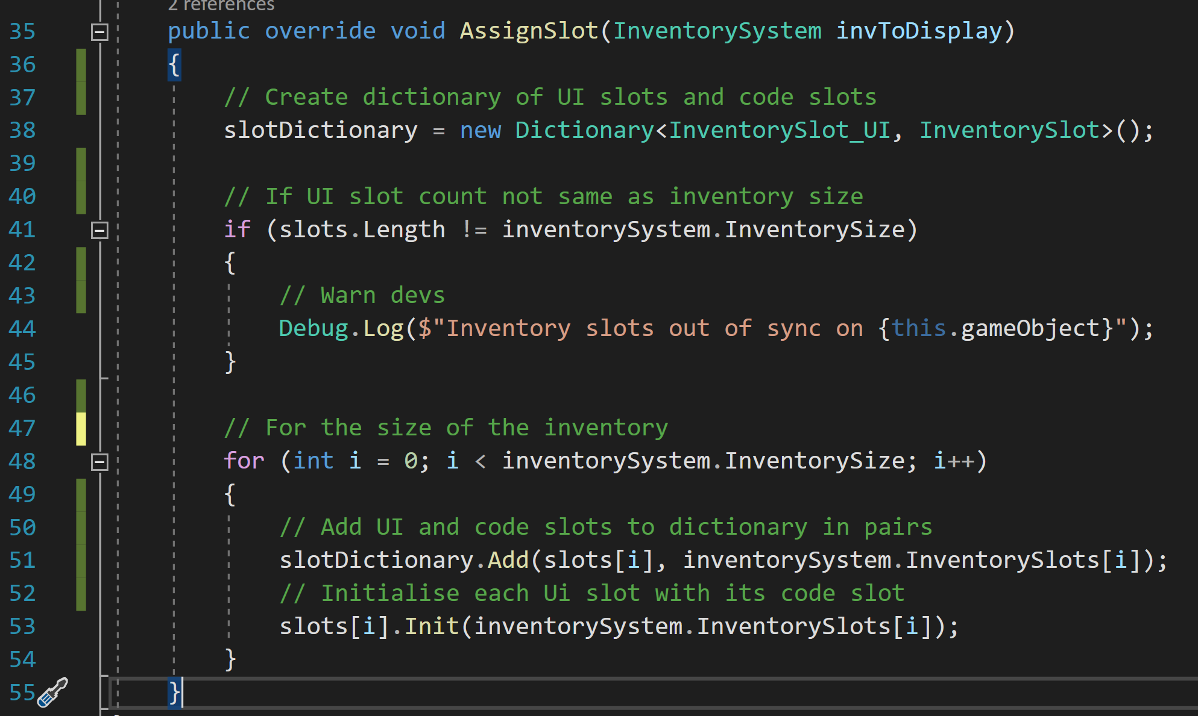

The AssignSlot method takes that inventory system and creates a new dictionary of Ui slots and code slots. It creates a warning if the length of the UI slots does not match the inventory size. For the size of the inventory, it adds the UI slots and code slots in pairs to the new dictionary before initialising the UI slots with their respective code slots.

### Inventory System Rework

At this point in the project, I realised that I had understood the inventory system incorrectly. What I was creating was a system using slots like those in Minecraft or RPGs which would house the items in stacks of limited size. The inventory itself was also created to be of a limited size and inventory management would be a feature.

How the inventory was intended to function would be more like a list. The inventory could hold all varieties of items with a limit on their quantities enforced only by data size constraints. Adding and removing items would only change the quantity listed next to the item. This is a much simpler inventory to make, and I do not need to follow a tutorial for this, though I am thankful for the insights and methods shown in the tutorial.

#### Inventory Item Data

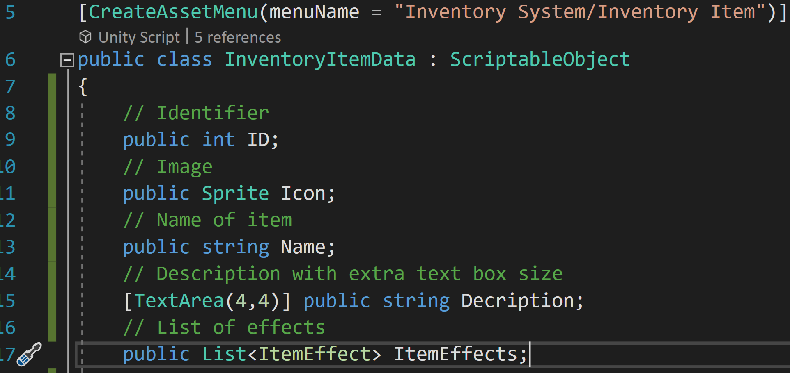

I started with the smallest unit of the inventory, the item data. This script starts with some variables including an ID, an icon, a name, a description with a large text box in the editor, and a list of effects used in gameplay.

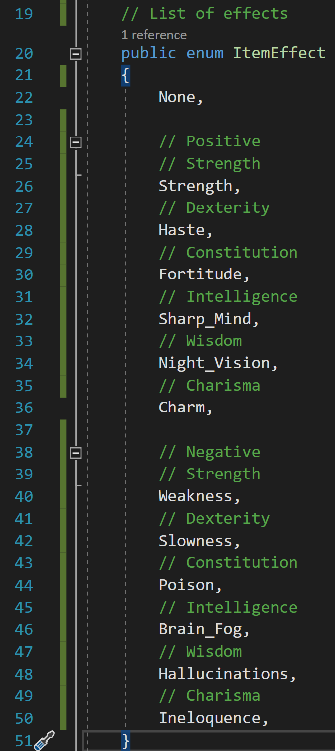

This list of effects draws from an enum created in the item data script. These follow the typical conventions of RPGs with the effects based on the stats of an adventurer in games like Dungeons and Dragons and Pathfinder. Alongside helpful positive effects, some items may have negative effects that the player may wish to avoid.

#### Inventory Stack

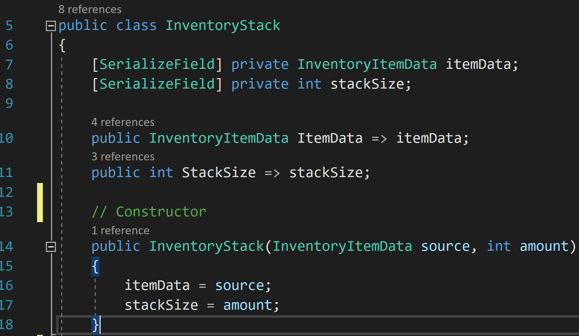

The inventory stack is my reimagining of the inventory slot. Unlike slots, stacks are not meant to be empty and will be deleted when they are empty. Stacks contain one type of item (such as a blue mushroom, red leaf) and a quantity of that item. They contain a constructor that forces the script to have the item and quantity already in it.

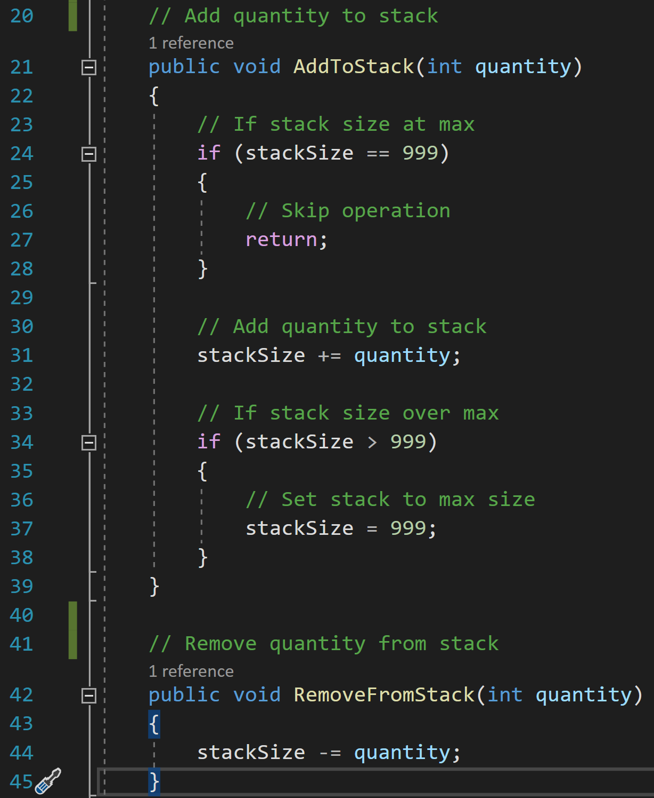

The stack script also contains methods for adding and removing items. The AddToStack method first checks if the stack is at maximum size and stops the method if it is to avoid unnecessary processing. Then, it adds the incoming quantity to the stack size before trimming it off if the stack size exceeds maximum size.

The RemoveFromStack method is much simpler and just removes the quantity from the stack.

#### Inventory System

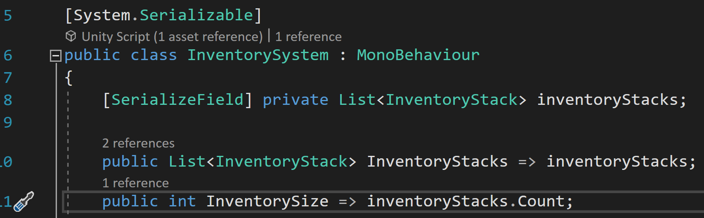

Much like the previous inventory system, the new inventory system has a list of stacks and a count of those stacks.

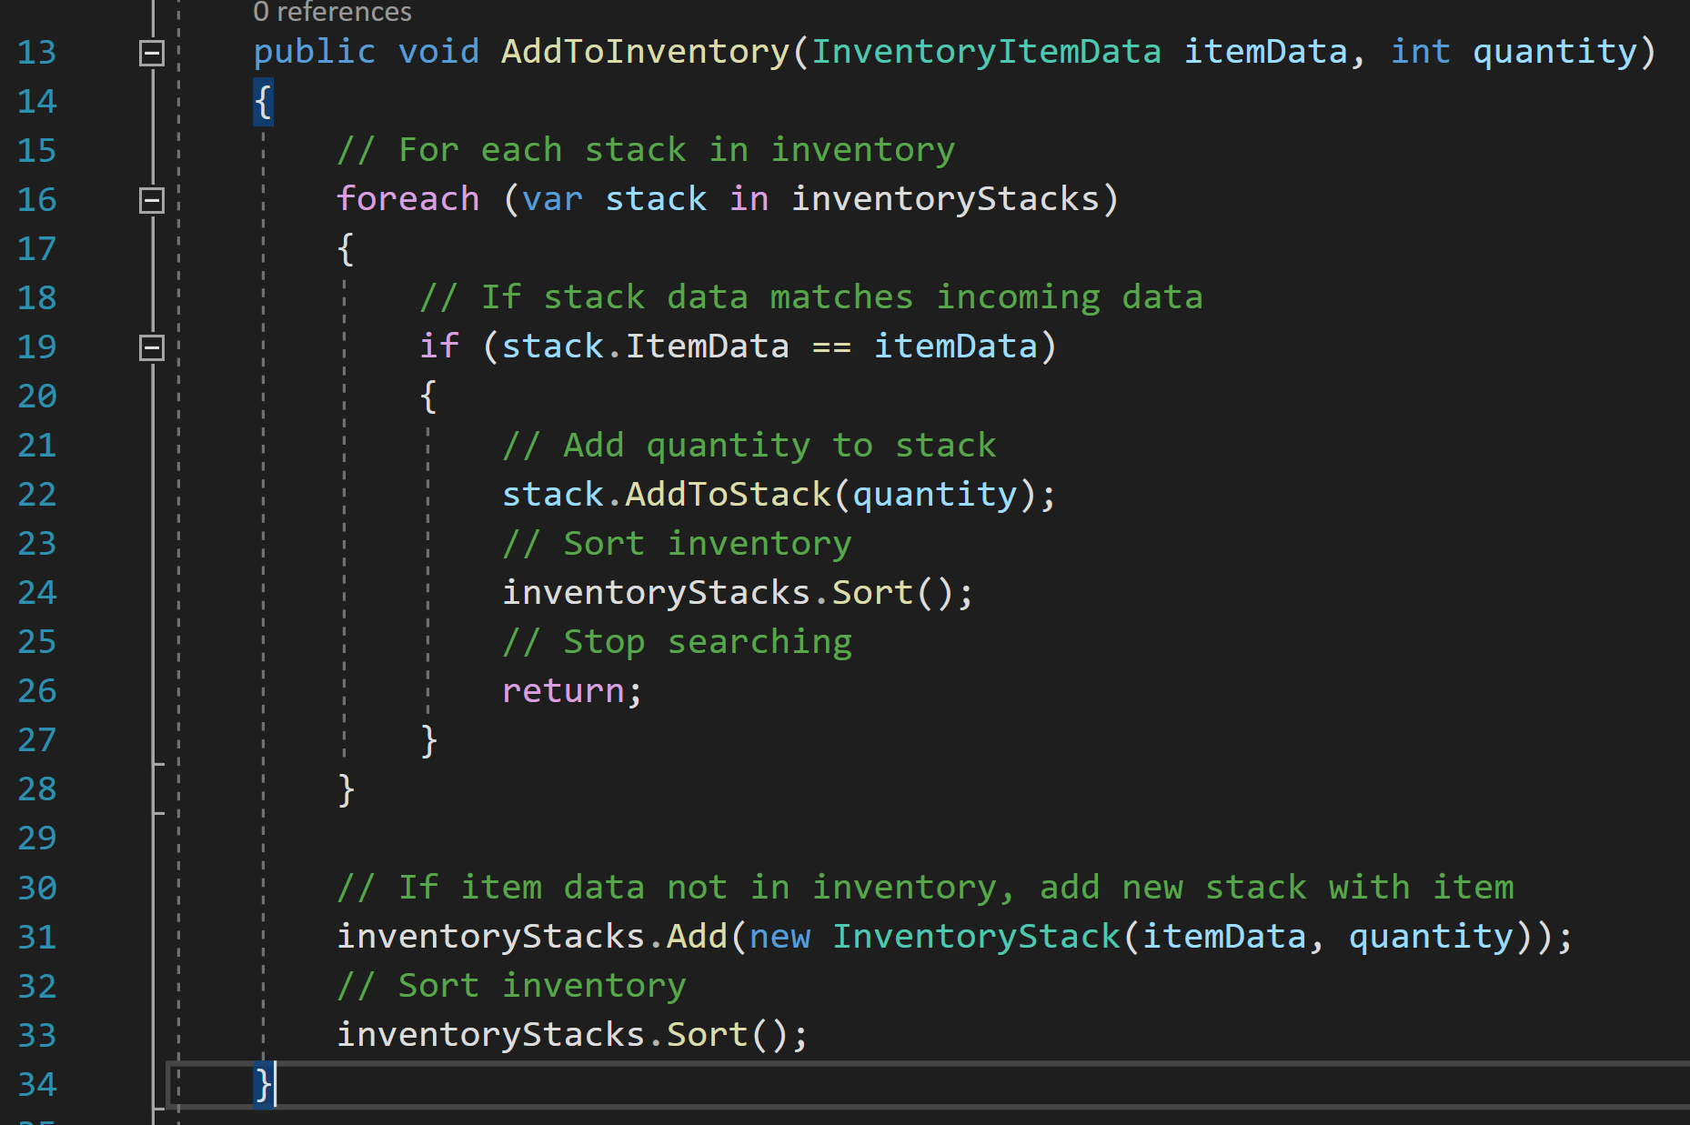

The first method in the inventory system is to add to a stack. First, it runs through each stack until it finds one with matching item datas. When it finds one, it adds the quantity to that stack’s size, sorts the inventory list, and returns the method as it has nothing more to do. In the case that the item isn’t already in the inventory, such as when discovering a new ingredient or making a potion, a new stack is generated with the item data and quantity, and the inventory is sorted.

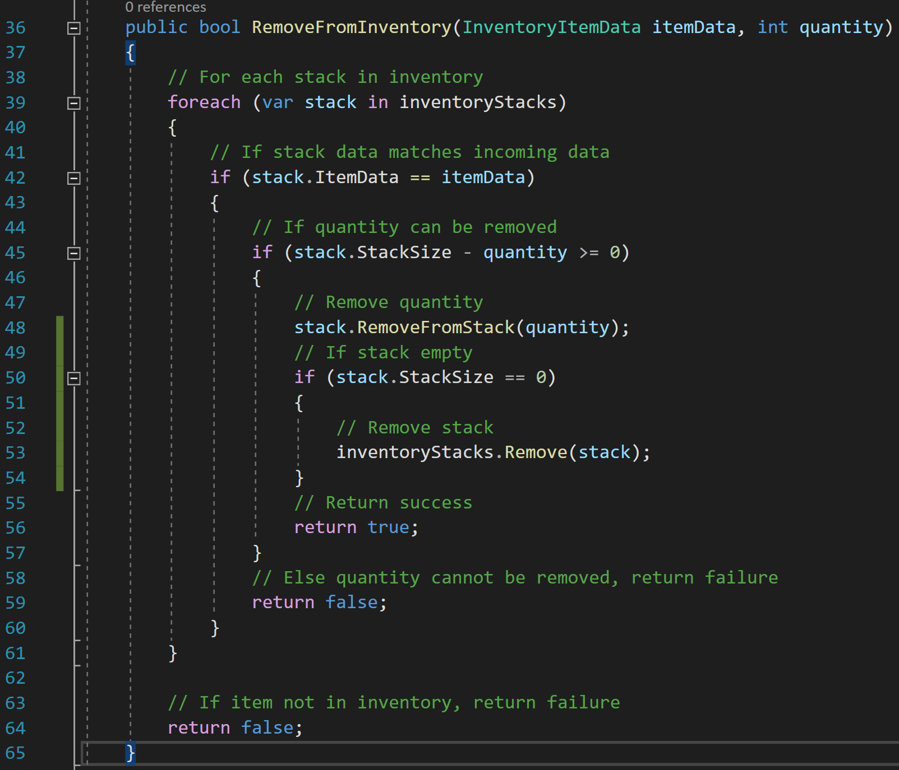

The other method implemented in the inventory system is RemoveFromInventory. This method removes a quantity from a stack and deletes the stack if needed. First, it runs through each stack looking for a stack with matching item datas. Then, it checks if the quantity can be removed from the stack, does so if it can, and deletes the stack if it becomes empty because of this. This is the only success condition. The method returns a failure state if the quantity cannot be removed from the stack, or if the item is not in the inventory.

#### Inventory Stack UI

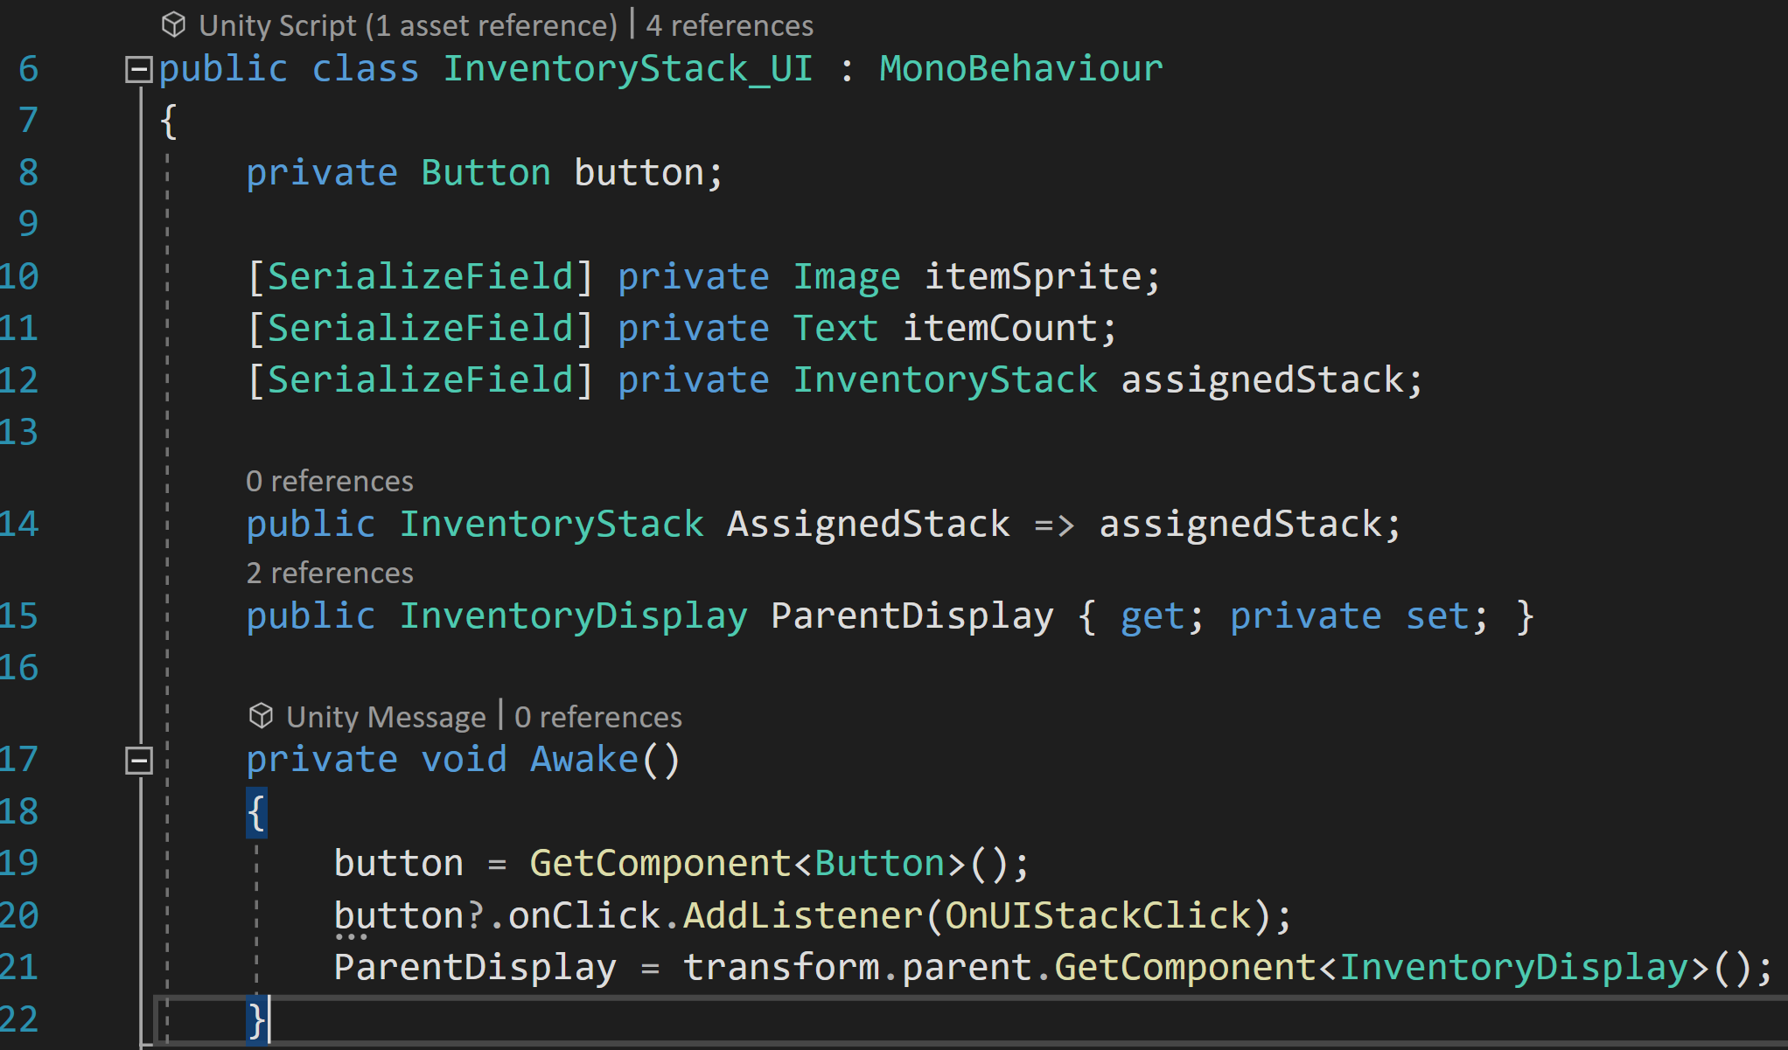

With the backend complete, I started work on the user interface with the stack UI. Much like the previous version, it has an image, text, a button, and a reference to its assigned stack, as well as a parent display.

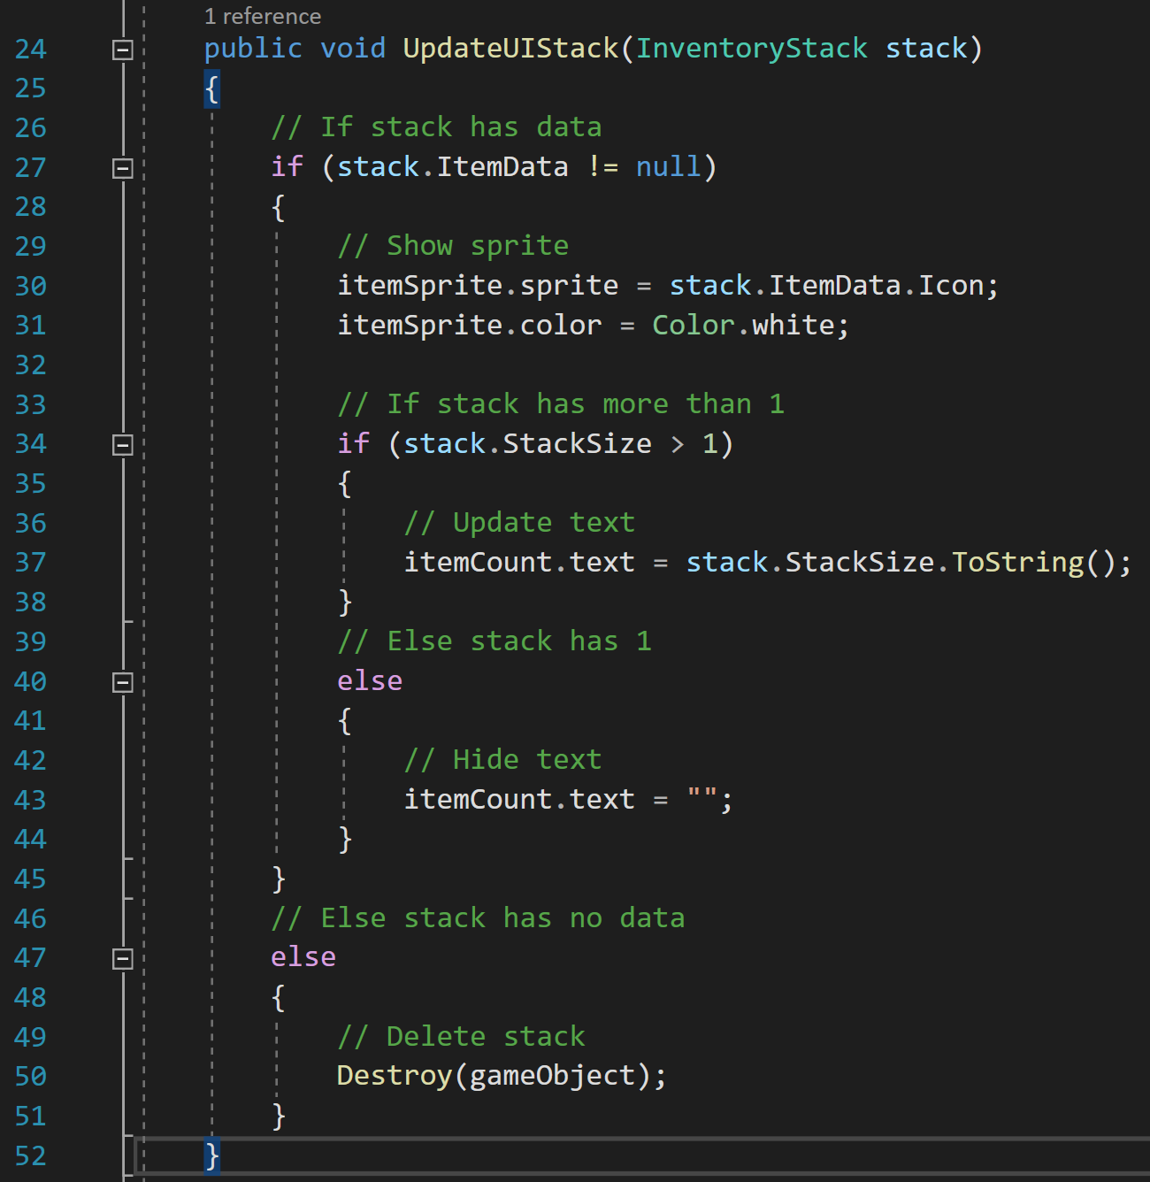

The first method of the UI stacks is to update them. It first checks if the code stack has data and deletes itself if it does not. If it has data, it shows the sprite of the item, then checks if the stack size of the item is more than 1 and shows the text if it is.

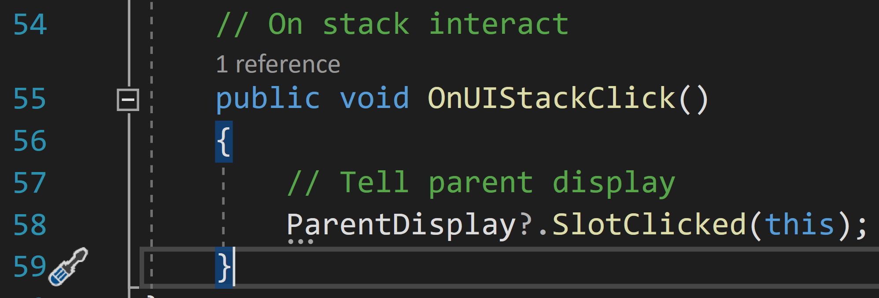

Finally, there is a small method to inform the parent display of when the stack is clicked on.

#### Inventory Display

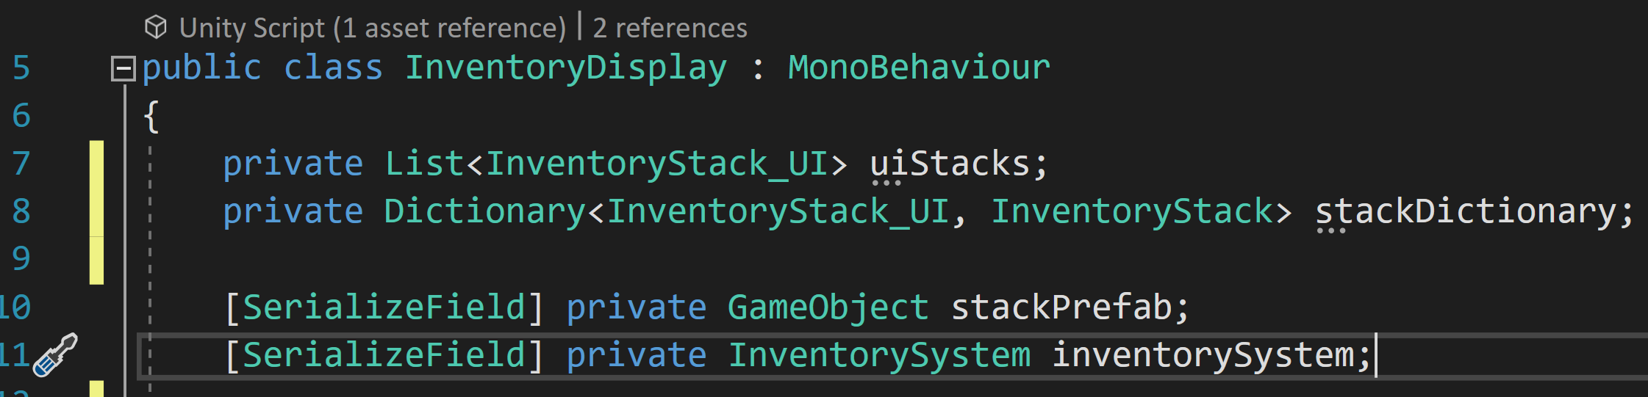

Unlike the previous inventory display, this inventory display is not meant to be inherited which makes the design of it much easier to work with. It starts by creating variables for UI stacks, a dictionary of UI and code stacks, a UI stack prefab, and its inventory system.

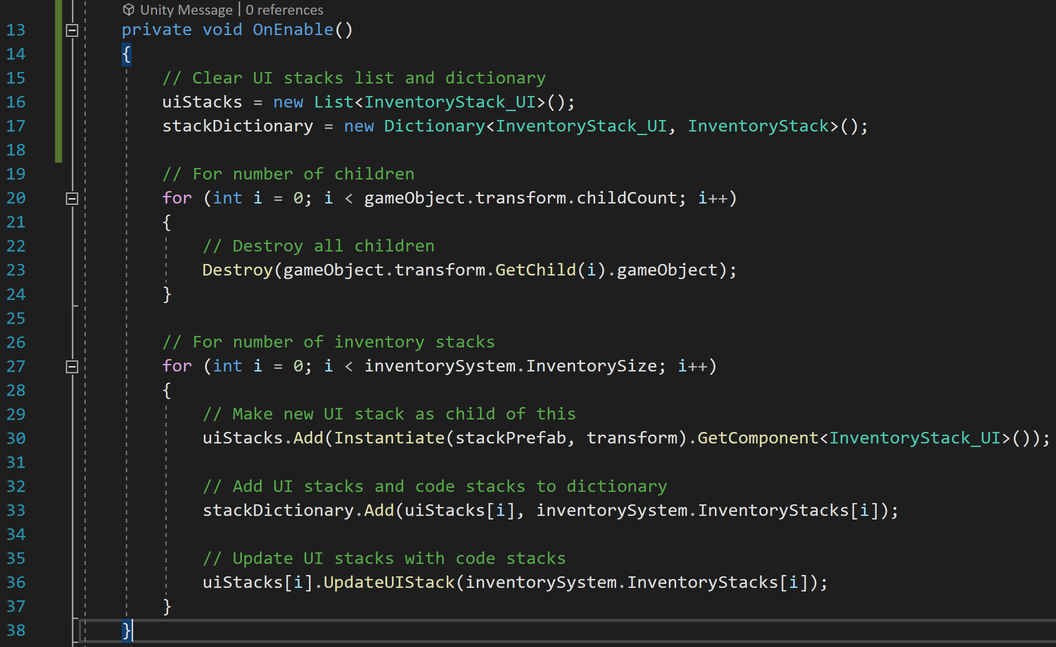

The bulk of the script is stored in the OnEnable method. This method deletes and remakes the UI stacks when the inventory panel is shown. First, the script clears the ui Stacks list and stacks dictionary. Then, the script gets all its children, which are the UI stacks, and destroys them. Next, for the number of code stacks in the inventory system, a new UI stack is instantiated and added to the list, the dictionary gets the new UI stack and code stack together, and the UI stacks are updated with the code stack’s information.

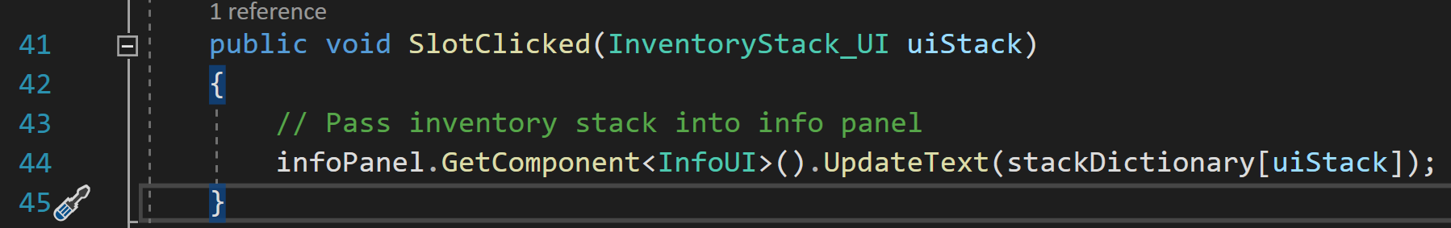

Finally, the Inventory Display has a method for passing the data received by a UI stack to the info panel for displaying information about the item to the player. It does so via the UpdateText method in the info panel script.

#### Info Panel

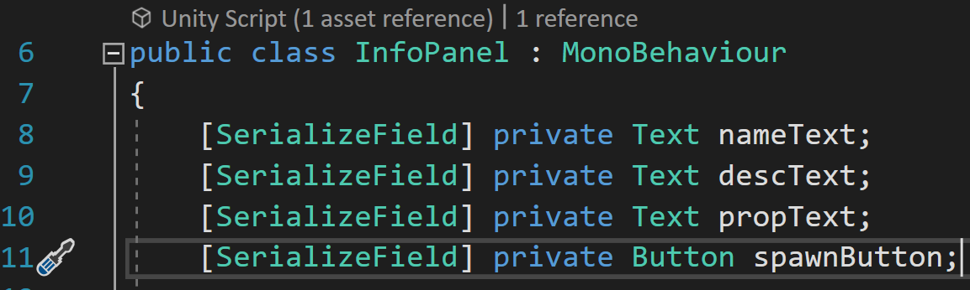

The info panel script is responsible for displaying specific information about an item. It starts by getting references to the various parts of the info panel including the name, description, and properties text boxes, and the spawn button used to create a physical object using the item’s information.

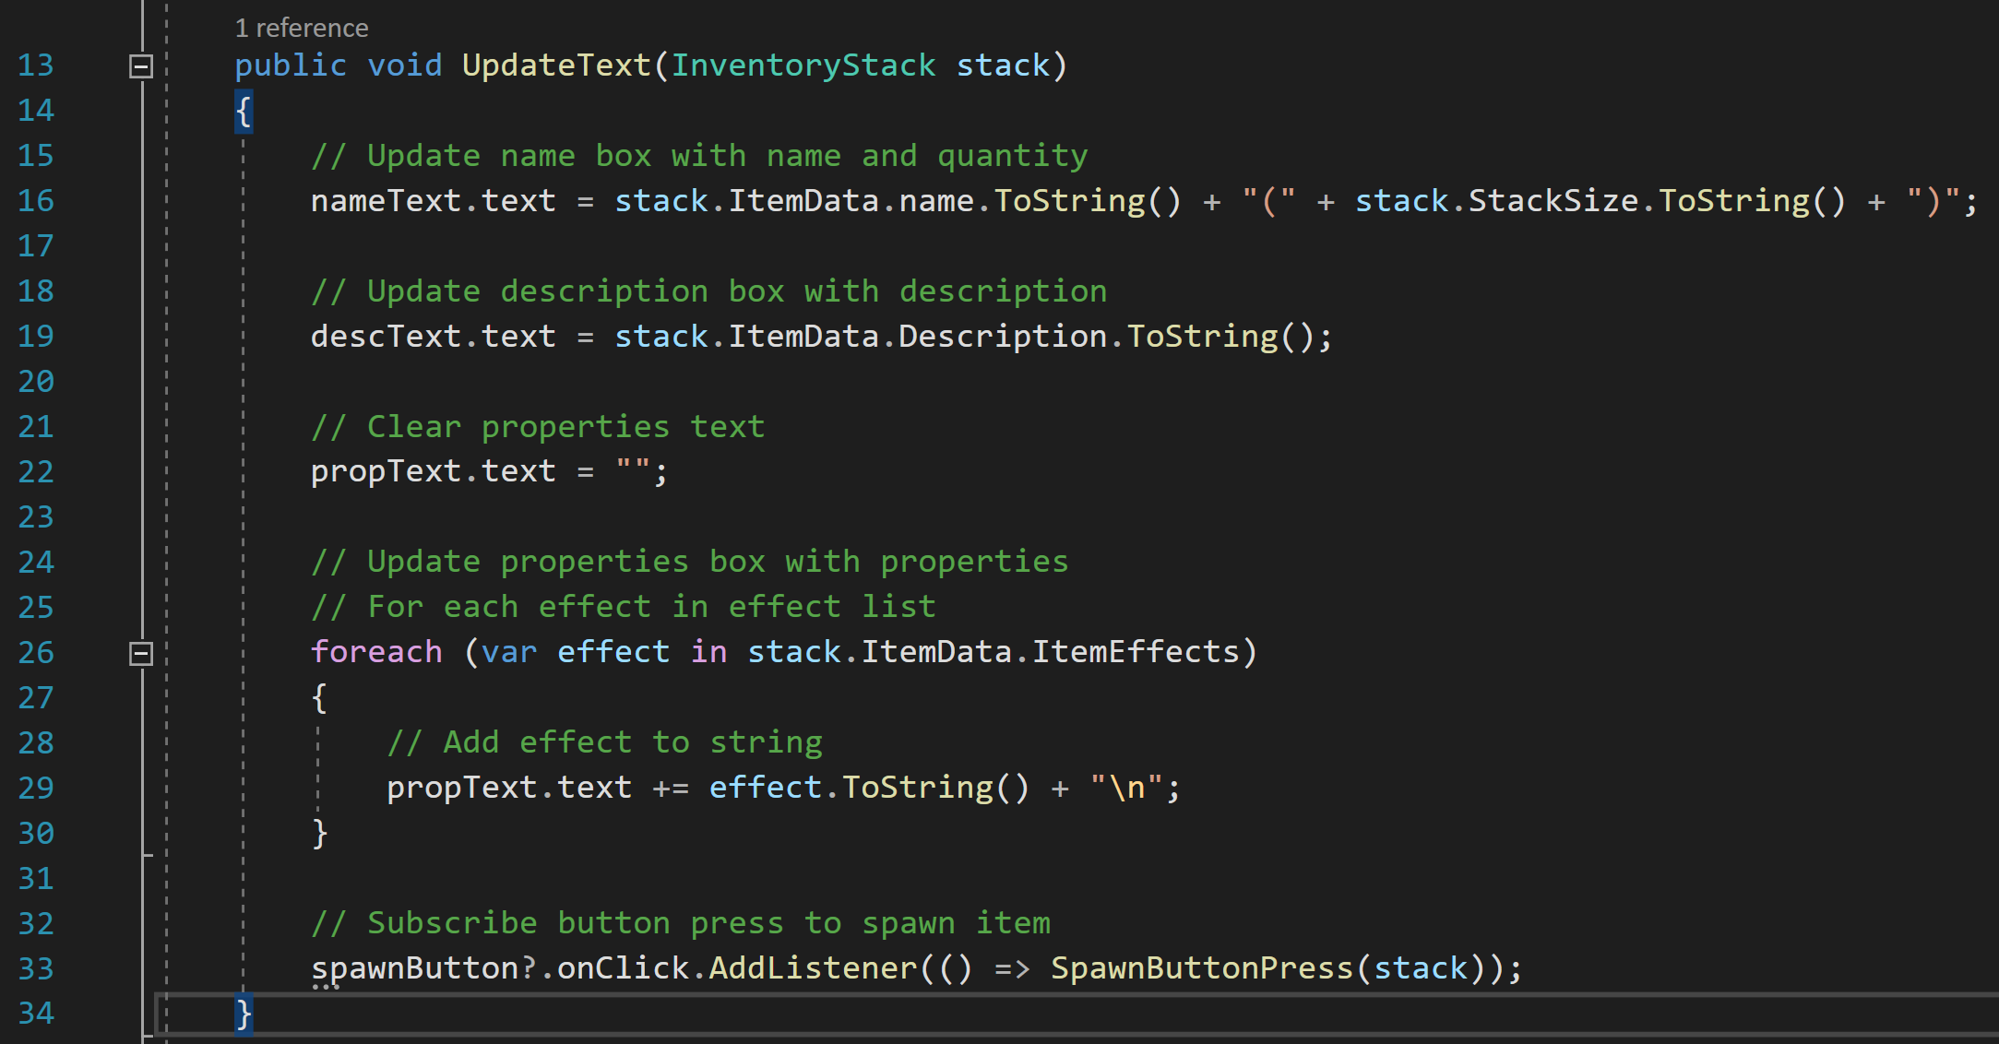

Next, the info panel has a method for updating the text it uses. This method takes in an inventory stack and updates the name text box with the item’s name and its quantity in brackets. It also updates the description text. For the properties, the method first clears the string used to empty the text box before individually adding each property’s name with ‘\n’ to make each subsequent property appear on a new line. Finally, the method subscribes the button’s OnClick event with the SpawnButtonPress method and passes in the stack.

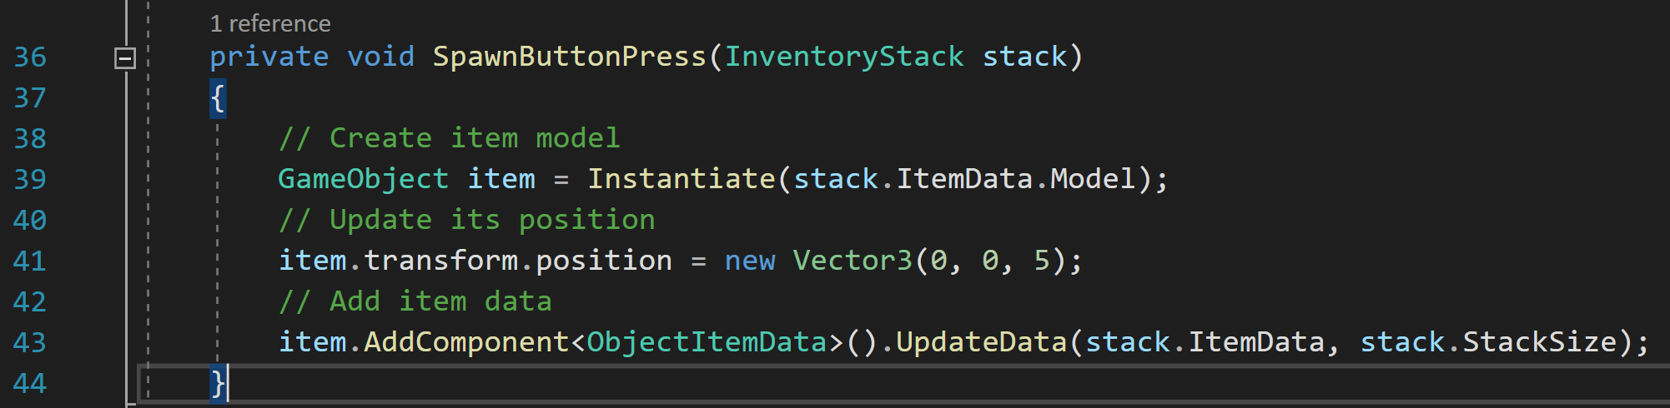

This method takes in an inventory stack and instantiates a new game object using that stack’s allocated model. Next, its position is updated to be in front of the player, and it is assigned an object item data with the stack’s data.

### Player Interaction Handler

With the inventory system complete, I turned my focus to how to interact with items.

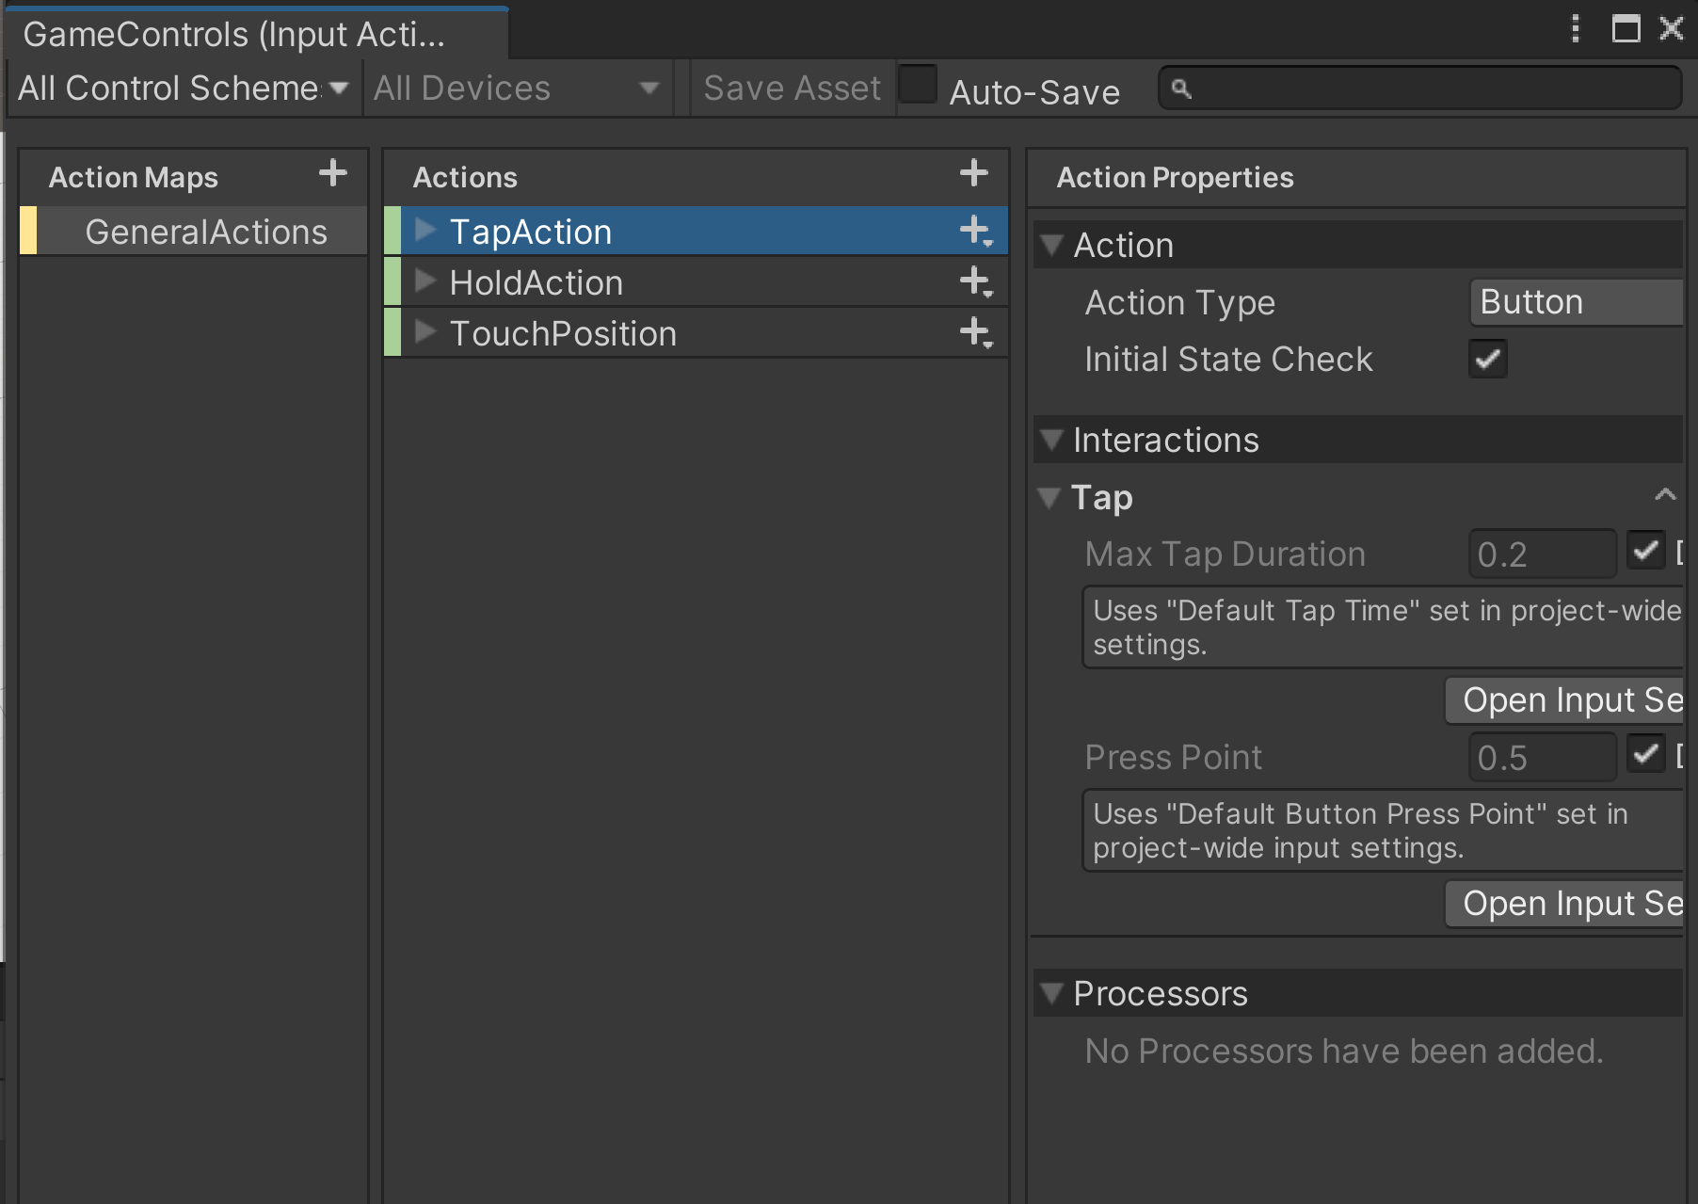

To begin handling interactions I created an Input Asset called GameControls with the Input System. In this asset, I created a control scheme using both a touchscreen and a mouse for testing, and added n action map. An action map is a collection of related actions, and a control scheme can have as many action maps as is needed. In this map I added 3 actions; one action for tapping, one for holding, and another to get the touch’s position. These were all I needed for basic interaction.

I also added the Player Input component from the Input System to the player object and fed in GameControls.

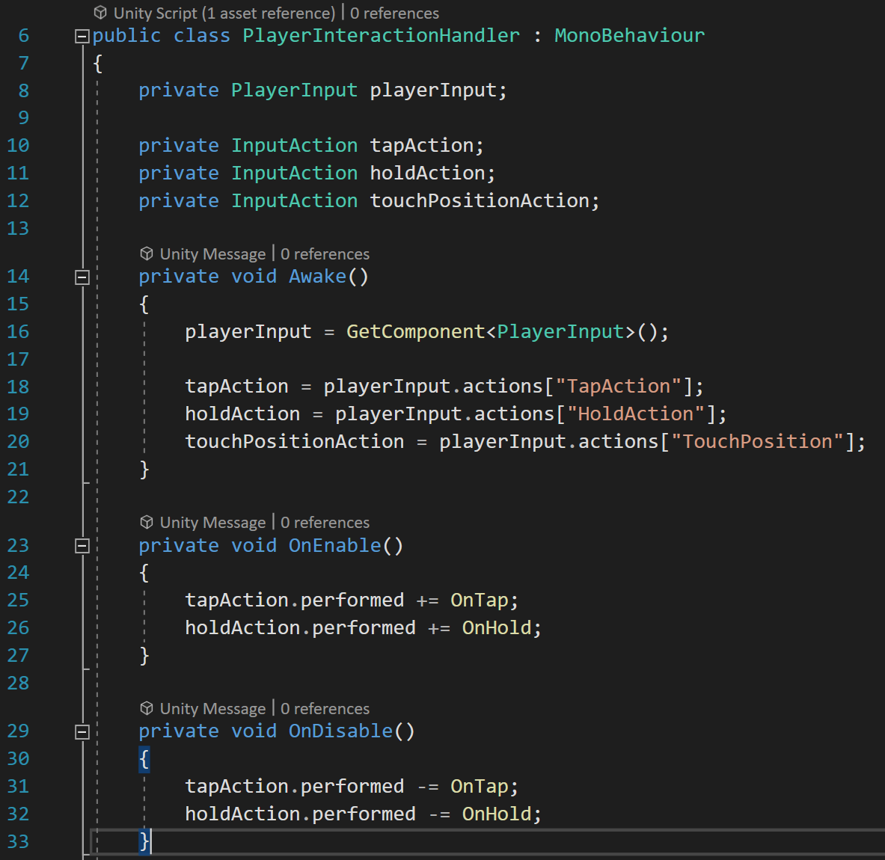

Next, I created a script called Player Interaction Handler which will handle interactions and inputs made by the player. This script creates variables for the Player Input component, as well as the 3 actions in the controls, which are filled with the necessary values on Awake. On enable, the actions are subscribed to either the OnTap or OnHold methods when performed, and are unsubscribed when disabled.

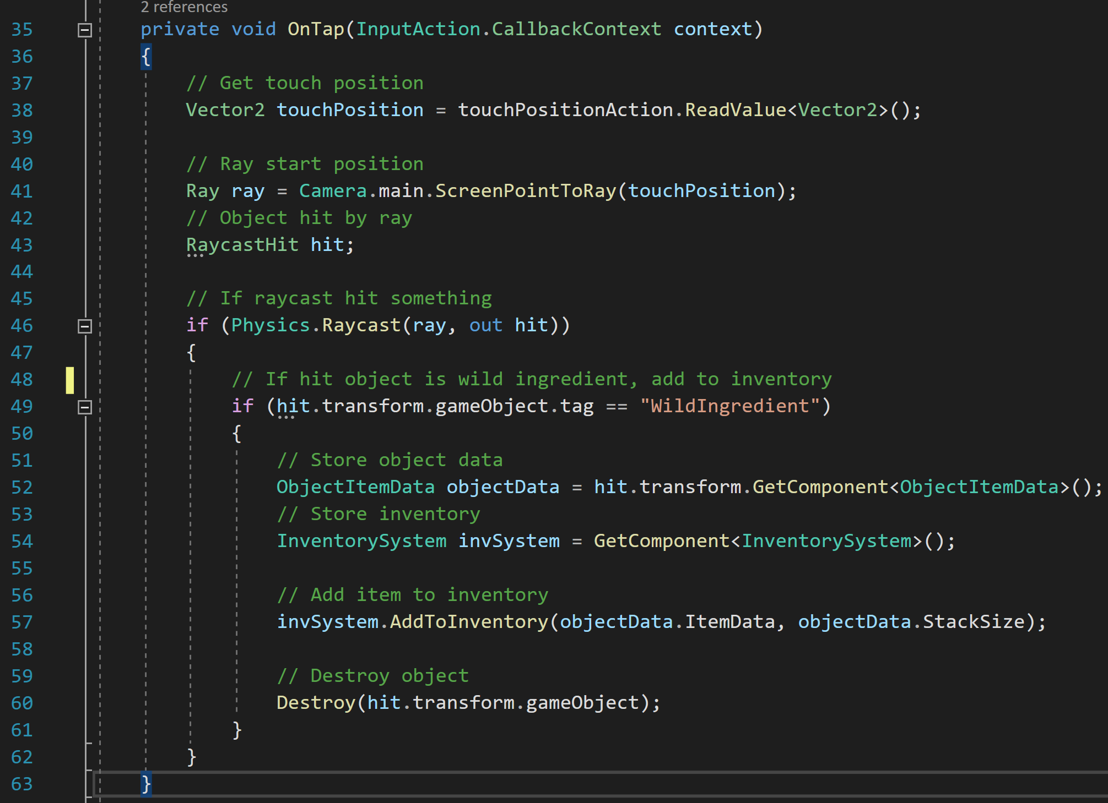

The OnTap method triggers whenever a tap is detected. It starts by getting the tap’s position, and setting up for a raycast using the tap’s position on the screen. It then checks if the raycast hit anything. If the raycast hit an object tagged WildIngredient, it will store that item’s data and get the inventory system of the player. It then adds that item to the inventory system and destroys the object so that the player cannot get an infinite number of them.

### Game Manager

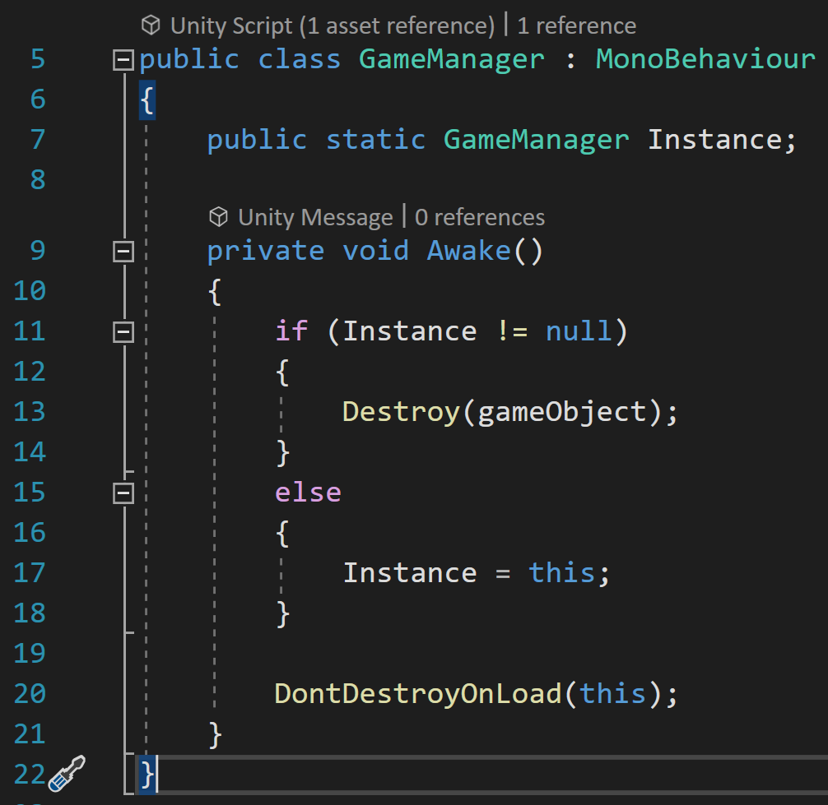

The game manager script allows a game object to persist through scenes. This script is attached to the player object so that the inventory does not get destroyed across scenes. It does this with a static variable that will be the same across instances of this script. If that variable is filled, the script destroys the game object it is attached to and fills that variable with itself if it is not. Then, it sets itself to not be destroyed when loading a new scene so that it persists.

# Evaluation